**If you want to compiling GPL, we need to build environment first.**

Step First: create a new virtual machine, click “Create a New Virtual Machine”.

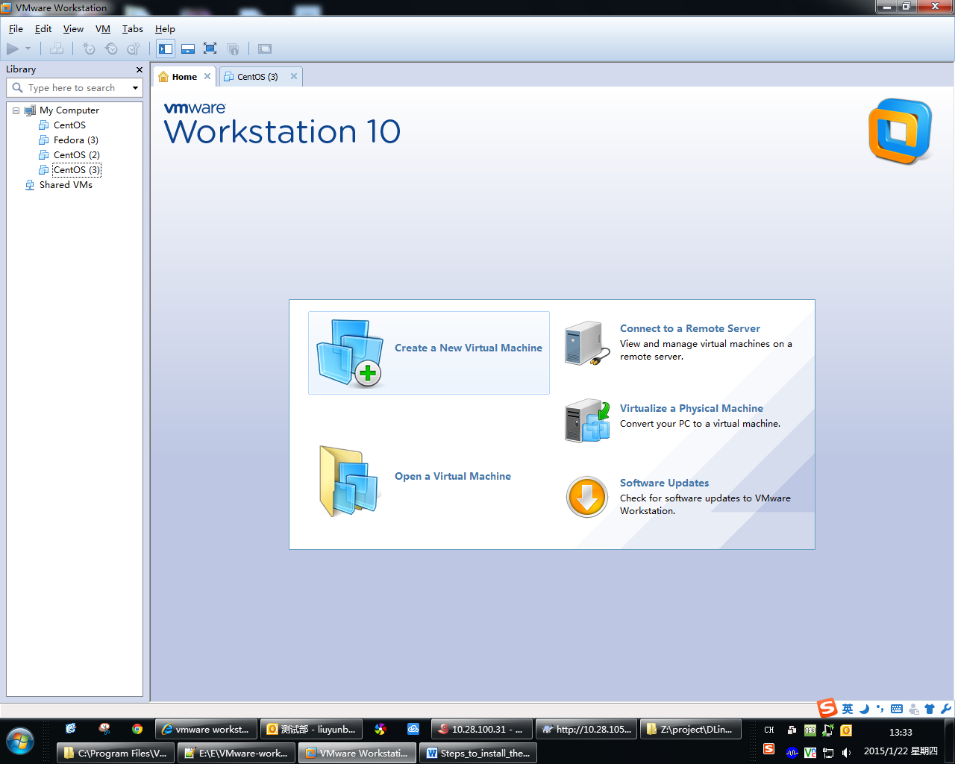

Step Second: please select “Typical(recommended)”. Then click “Next”.

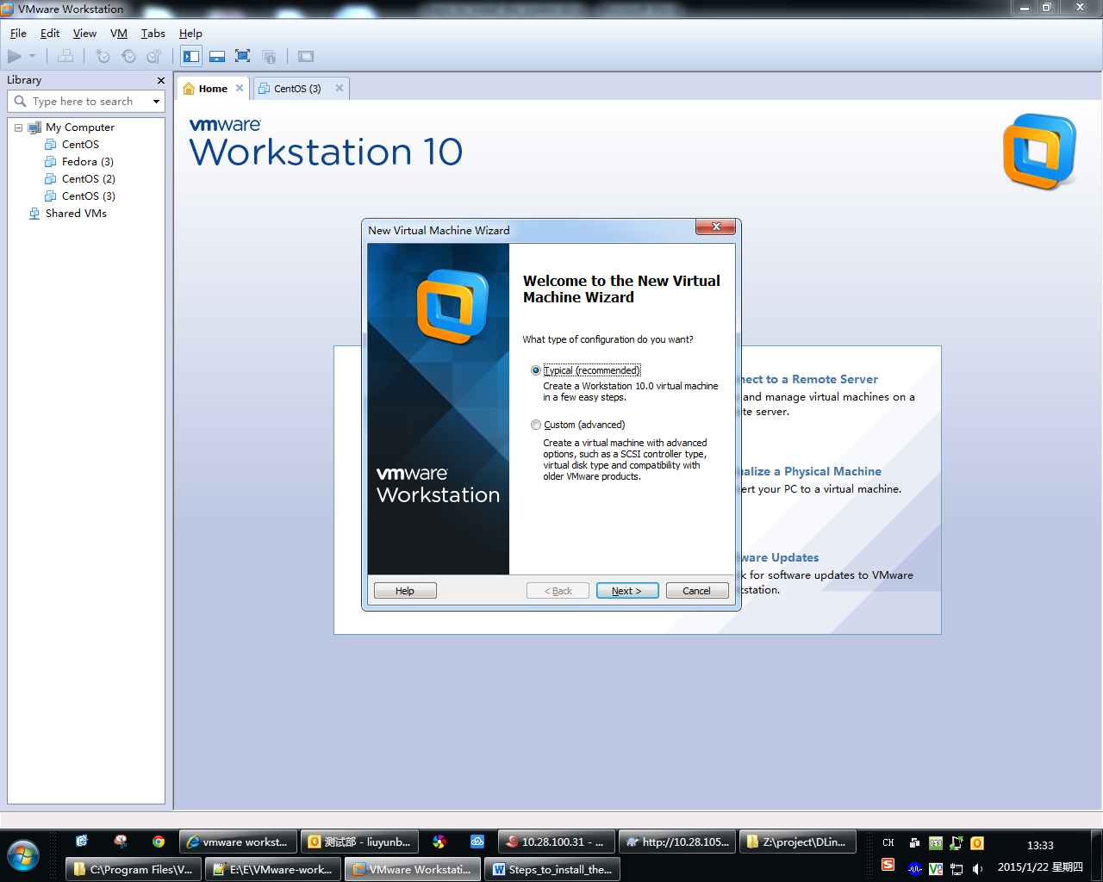

Step Third: please select “I will install the operating system later”. Then click “Next”.

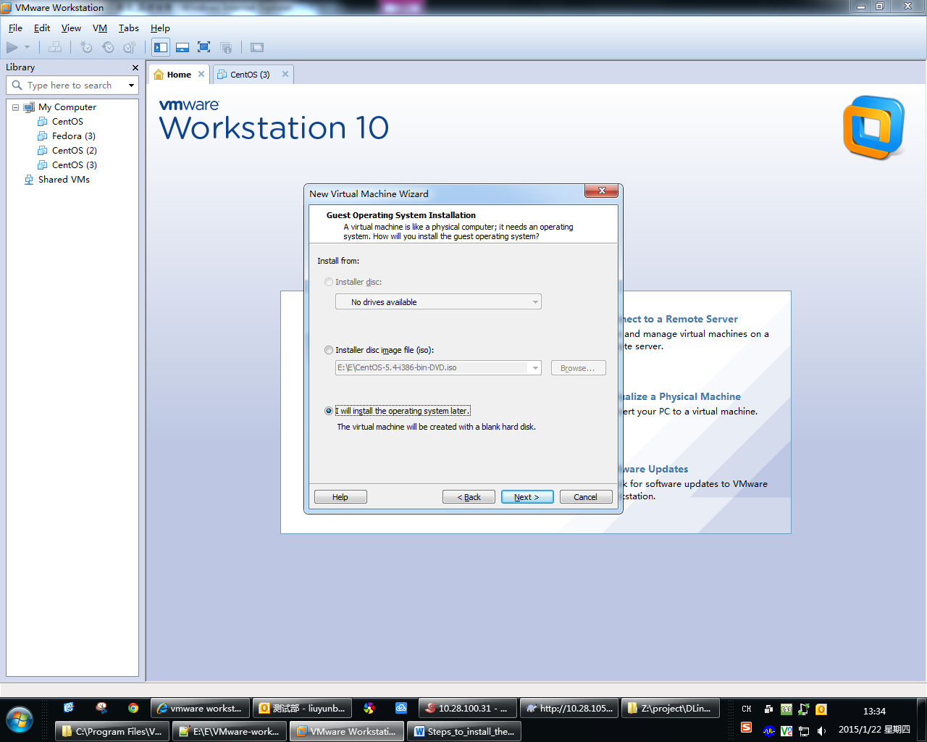

Step Fourth: Guest operating system select “Linux”, Version selest “CentOS”. Then click “Next”.

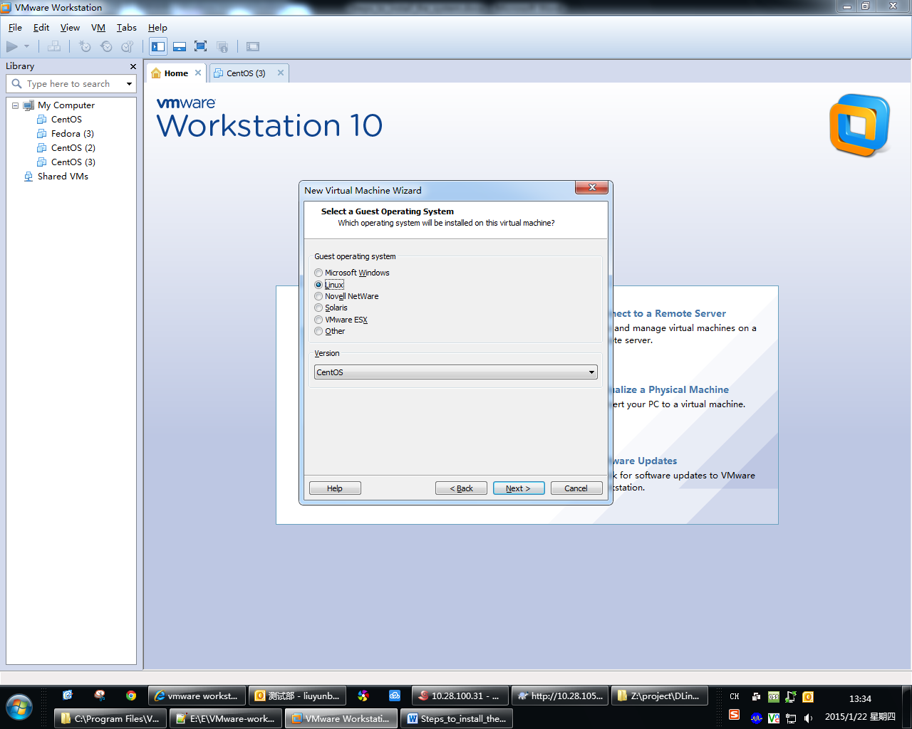

Step Fifth: set the virtual machine name. Then click “Next”.

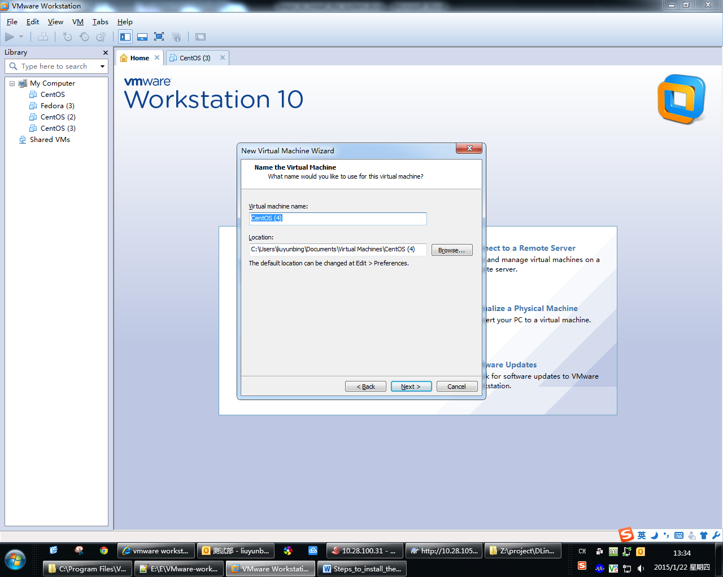

Step Six: please set the following screenshot. Then click “Next”.

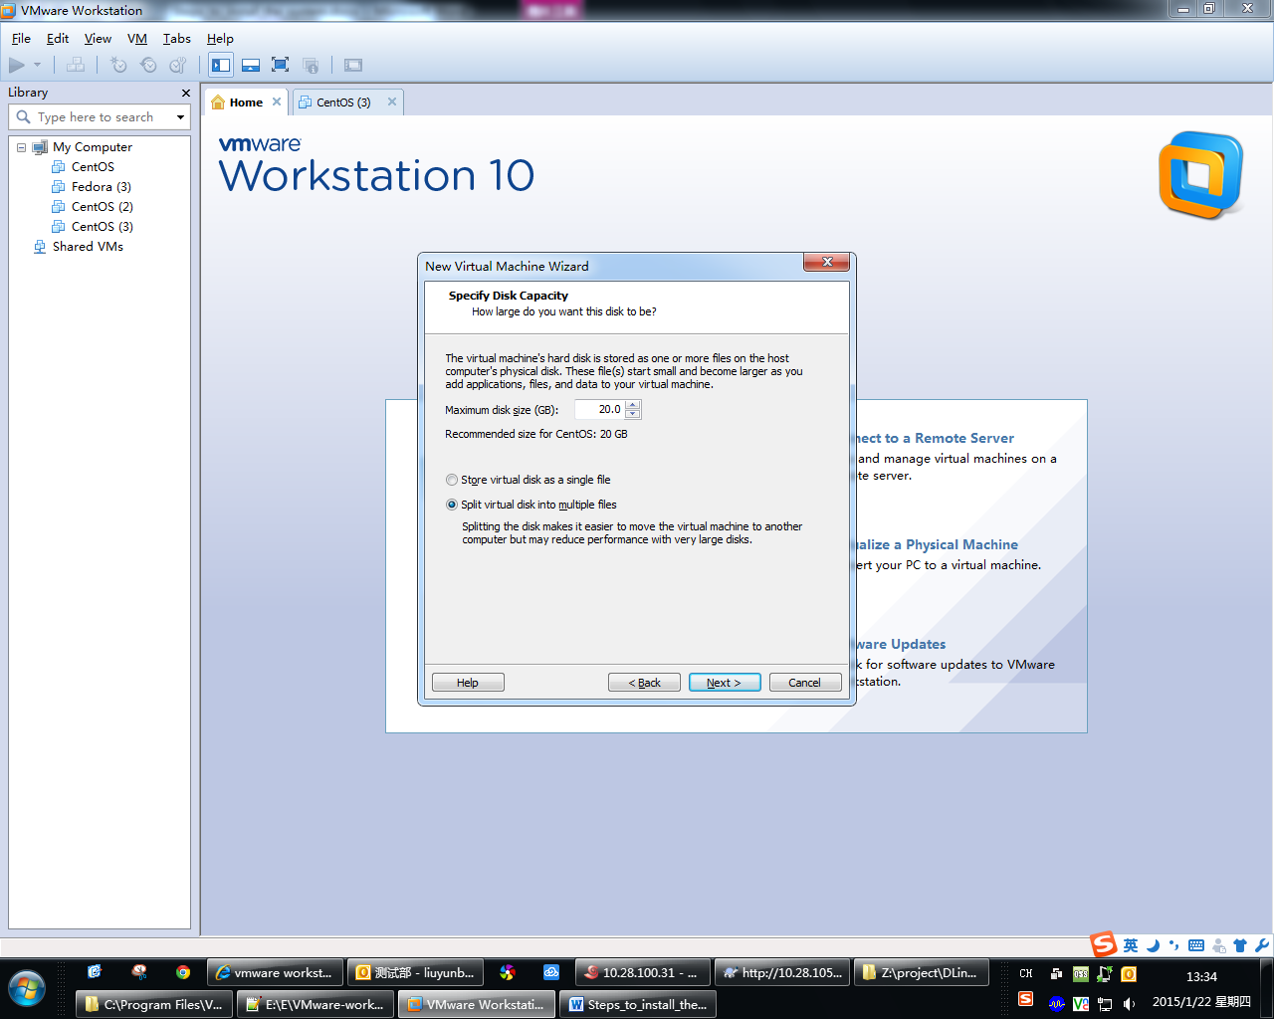

Step Seven: click “Finish” to create the virtual machine. Then you can install the system CentOS.

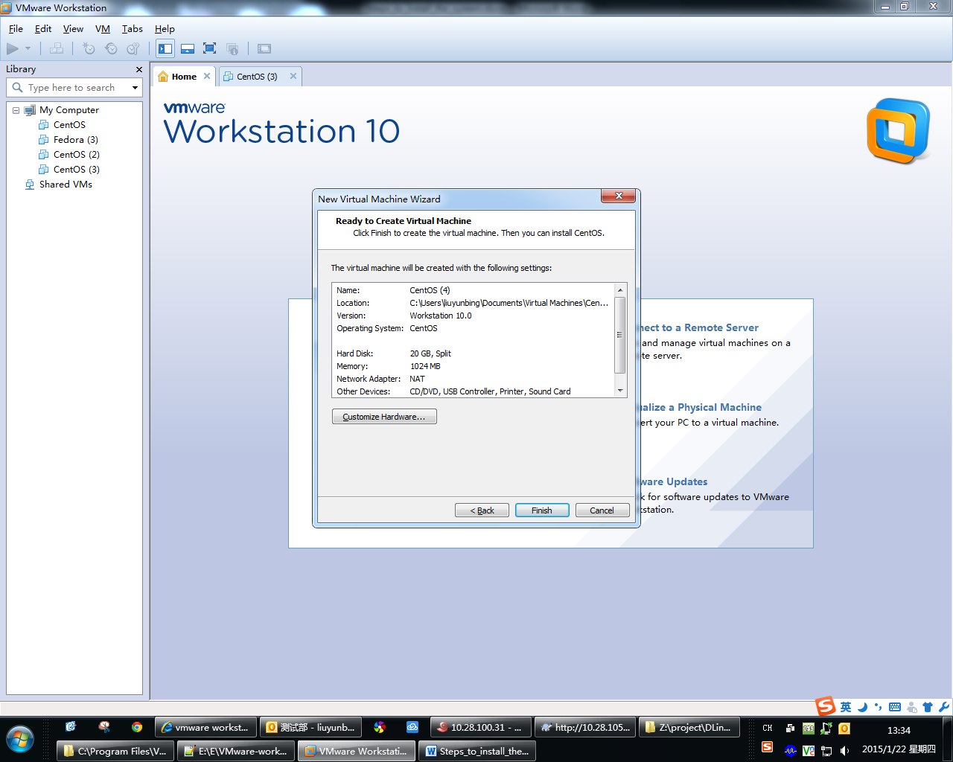

Step Eight: click “Edit virtual machine setting”, to setting the Mirror path.

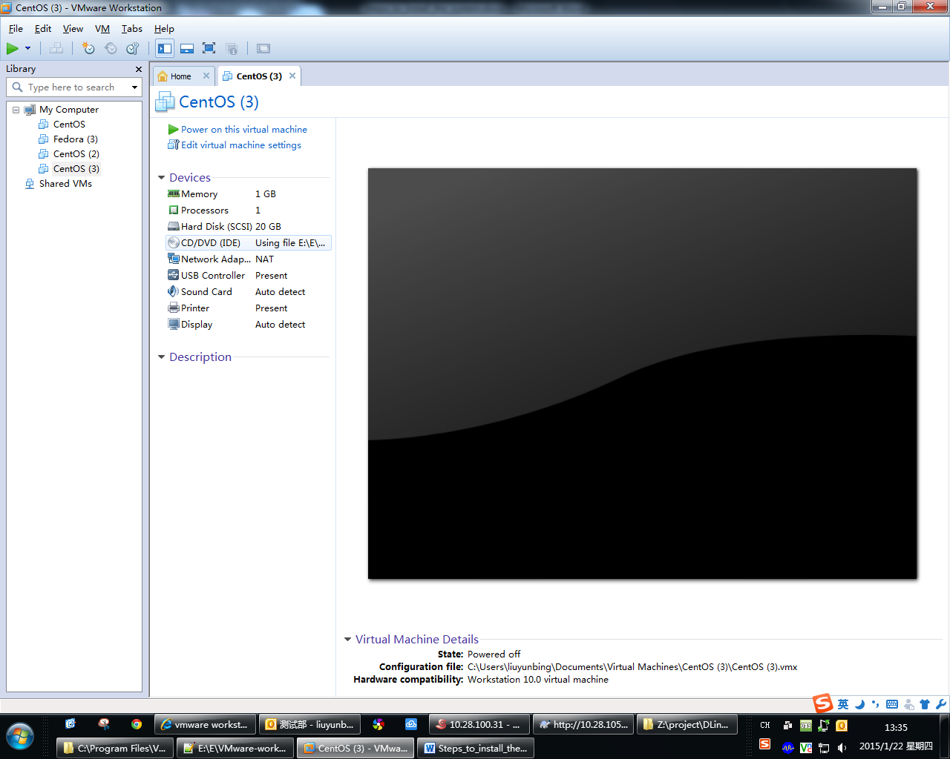

Step Nine: click “CD/DVD (IDE)”, select “Use ISO image file” and click “Browse…” to open the image file. Then Click “OK” to finish the setting.

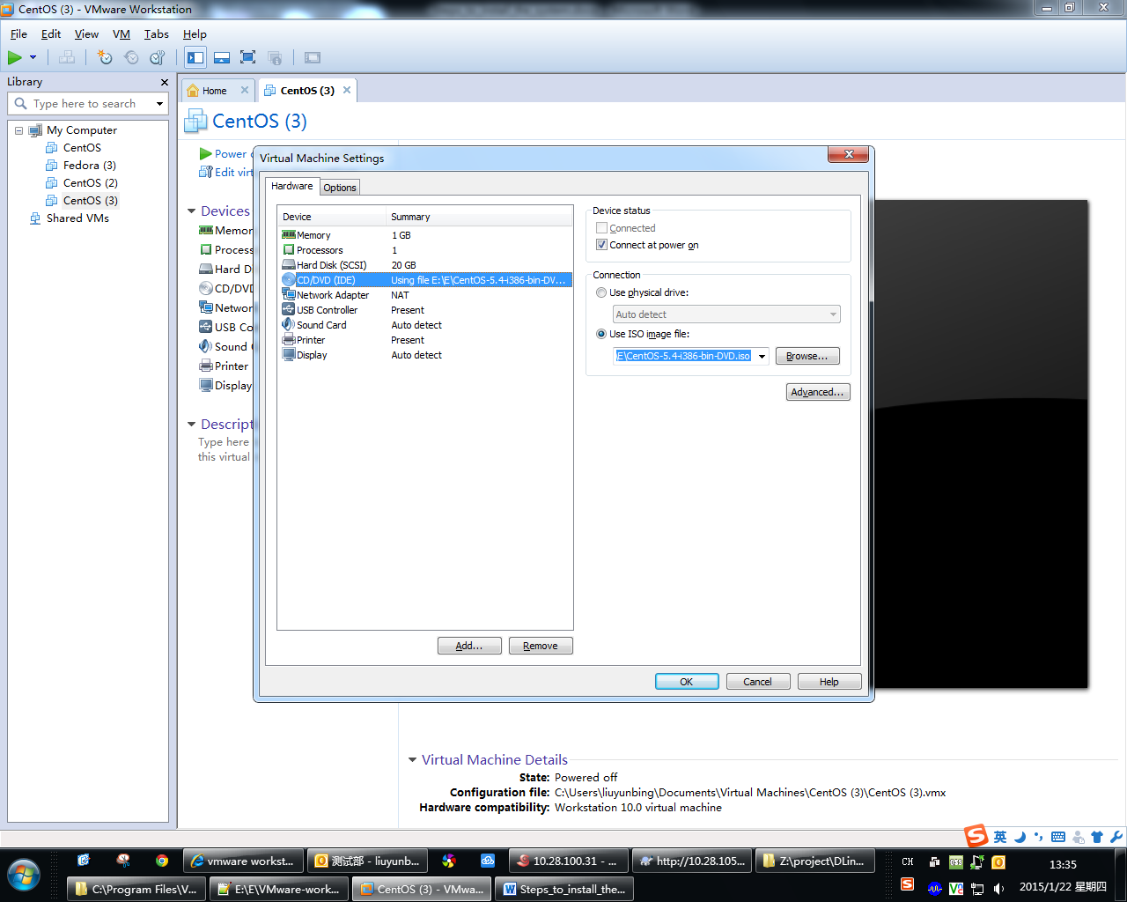

Step Ten: click “Power on this virtual machine” to install the system.

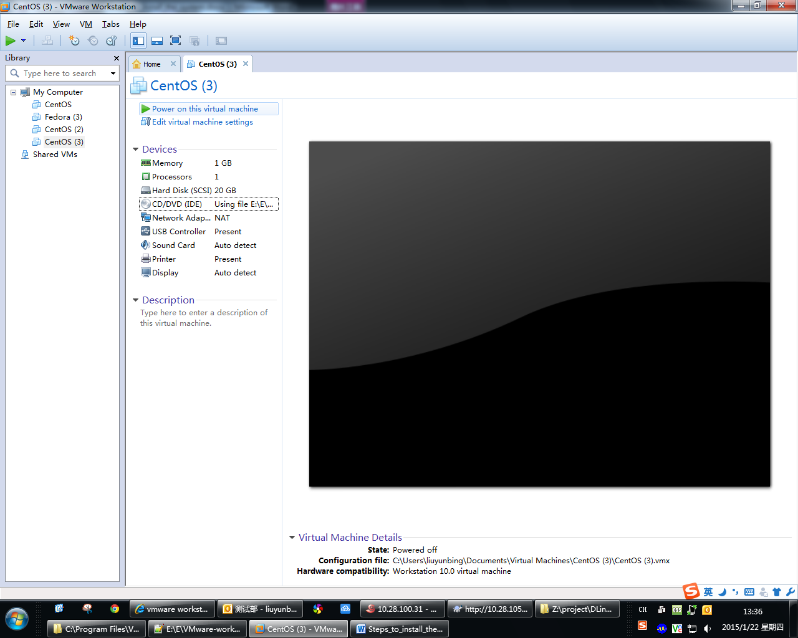

Step Eleven: click “OK” to next.

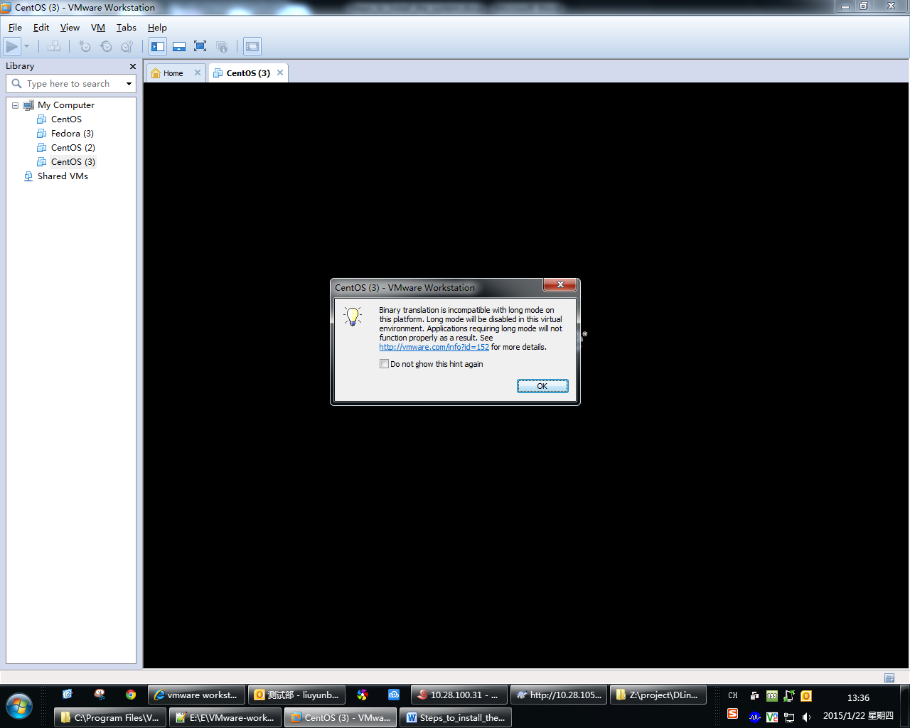

Step Twelve: if you see the following screen, you can begin installing the system. Press the “ENTER” key to install the system.

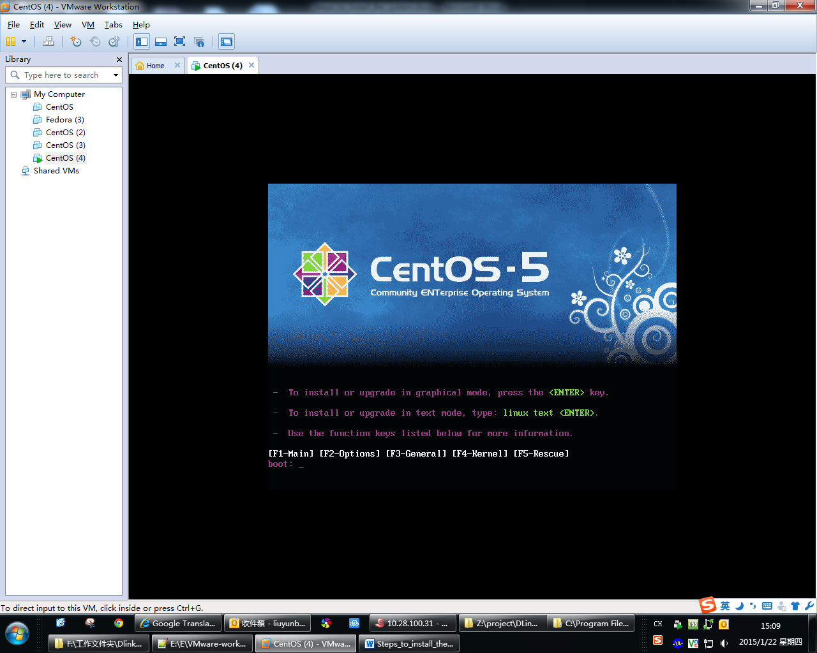

Step Thirteenth: select “Skip”.

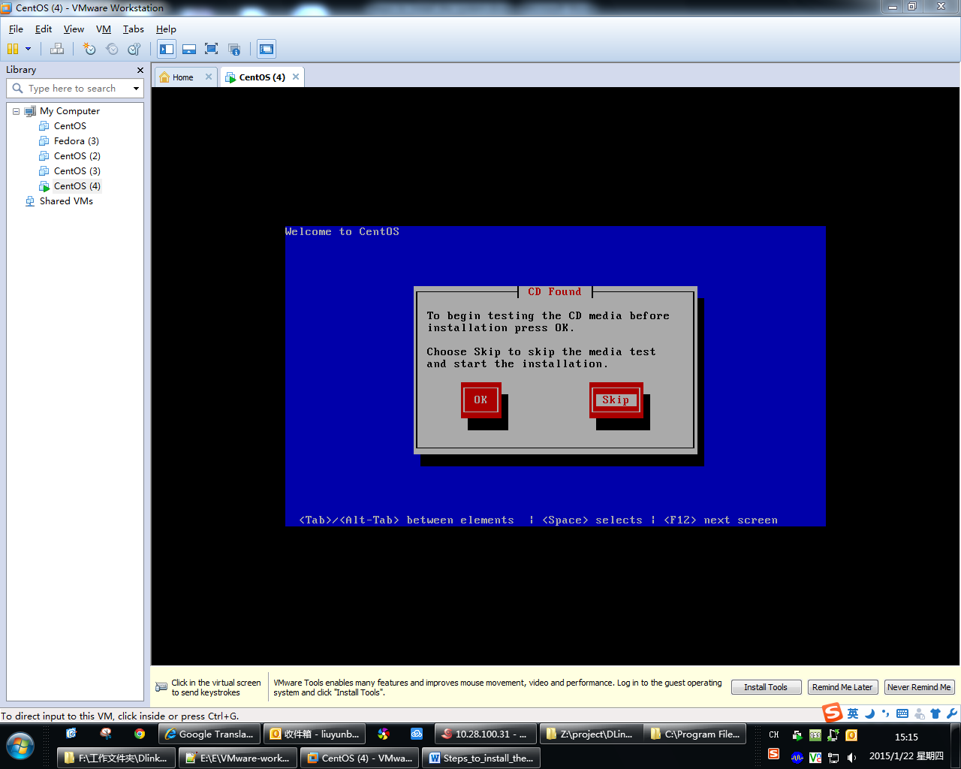

Step fourteenth : click “Next”.

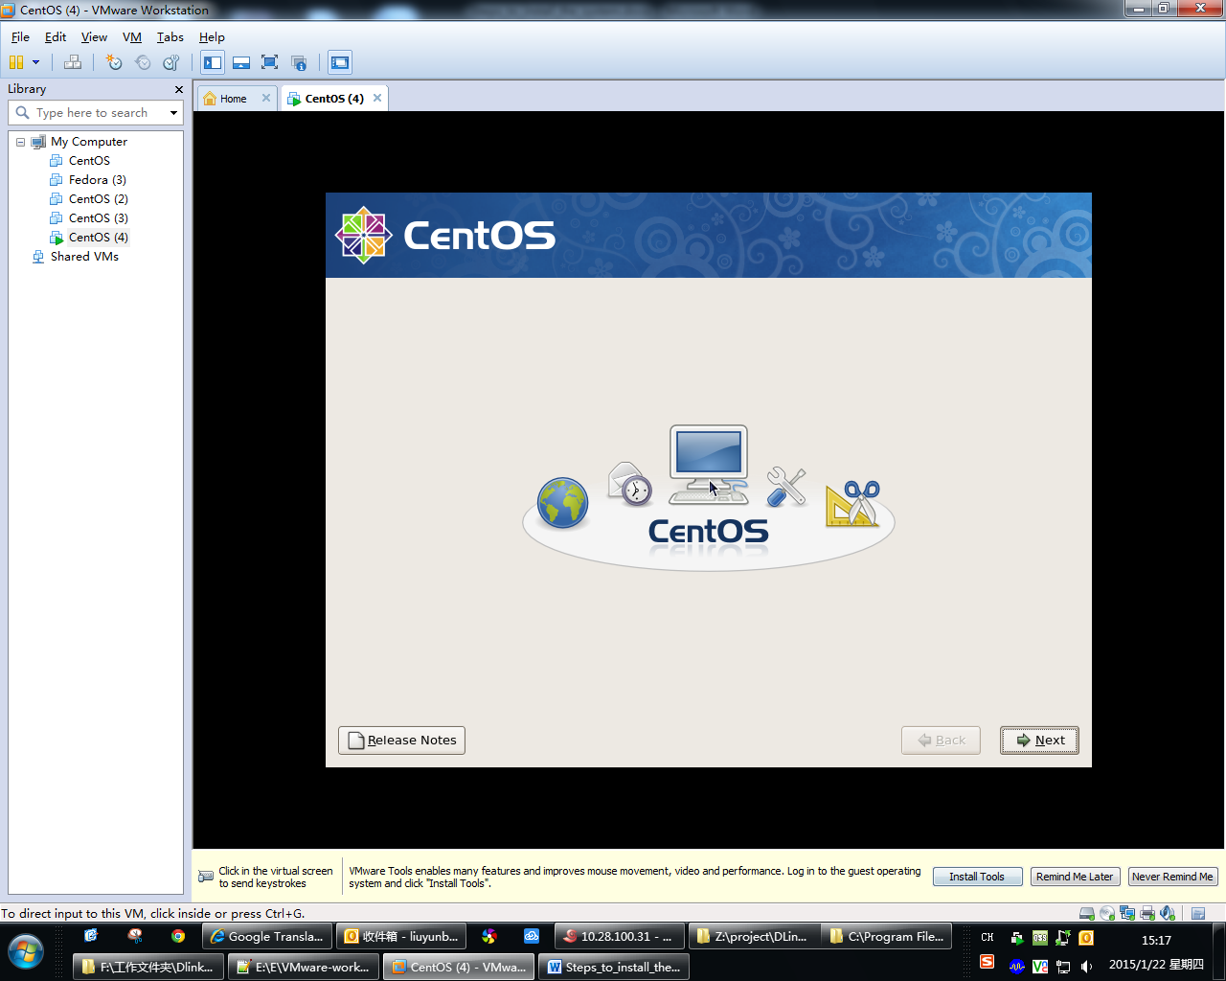

Step fifteenth: select “English(English)”.Then click “Next”.

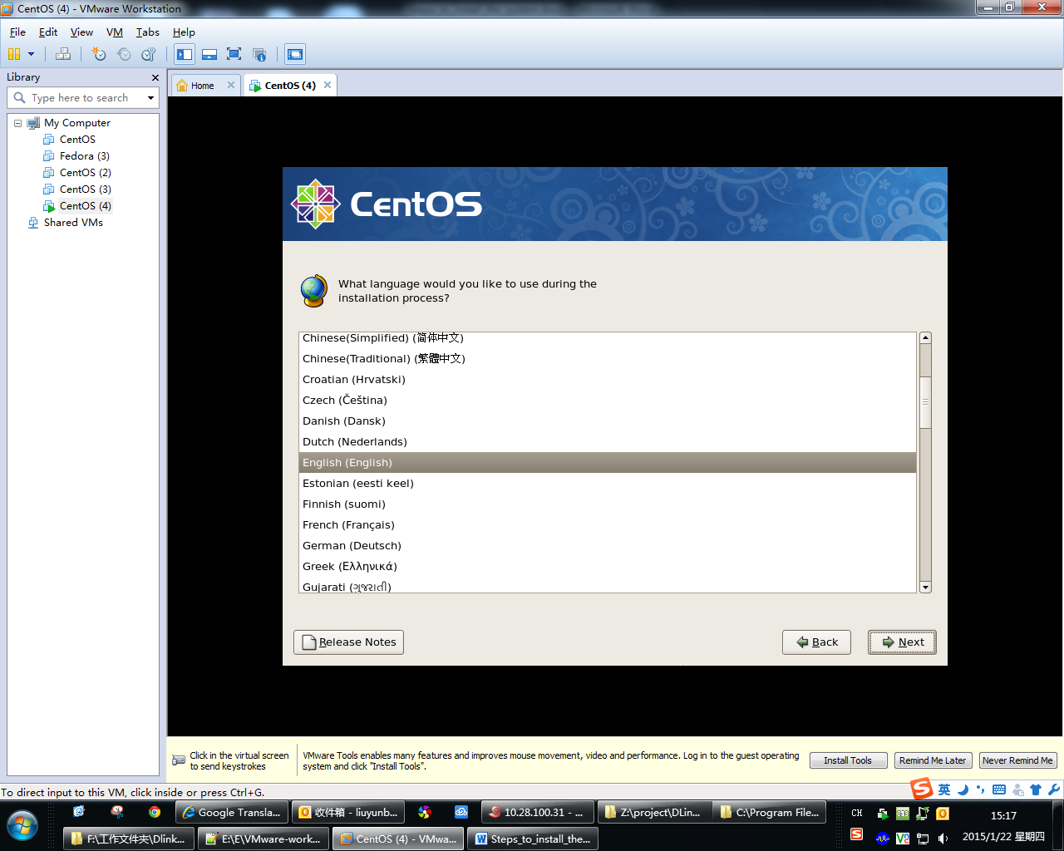

Step Sixteen: the appropriate keyboard select “U.S.English” for the system

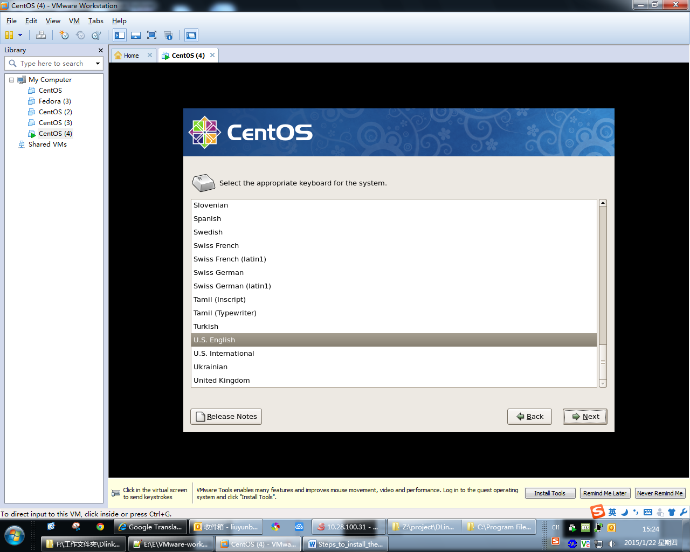

Step Seventeen: select “yes”.

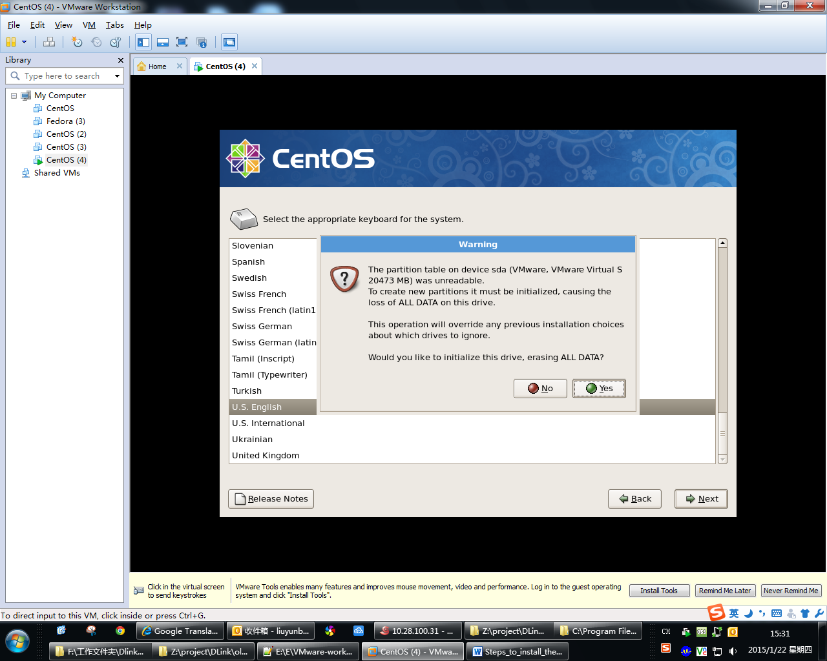

Step Eighteen: please set the following screenshot. Then click “Next”.

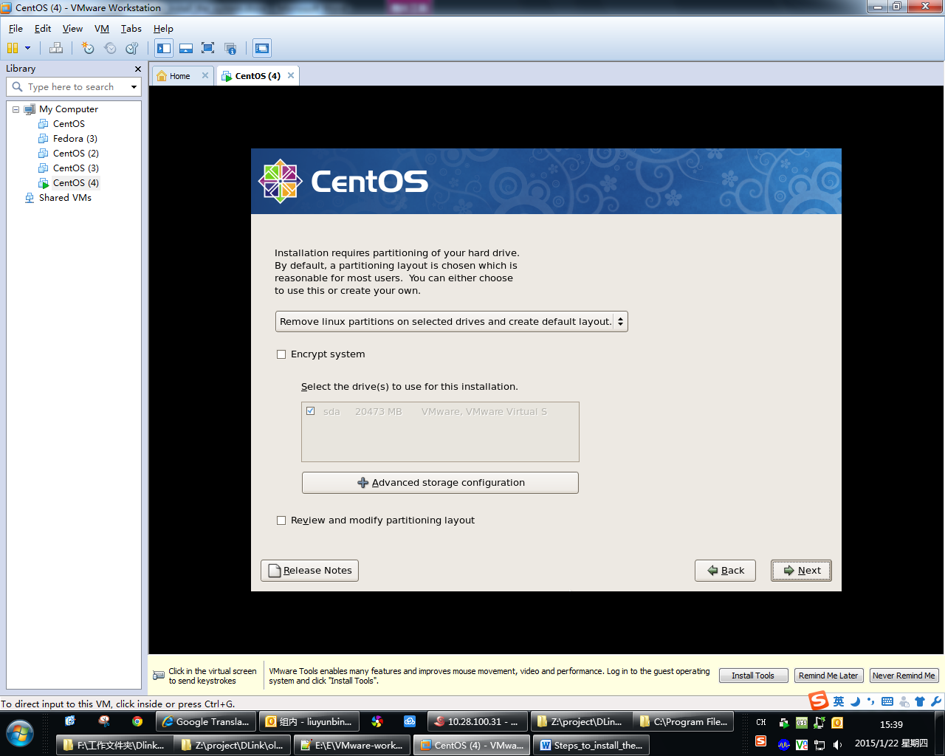

Step Nineteen: select “yes”.

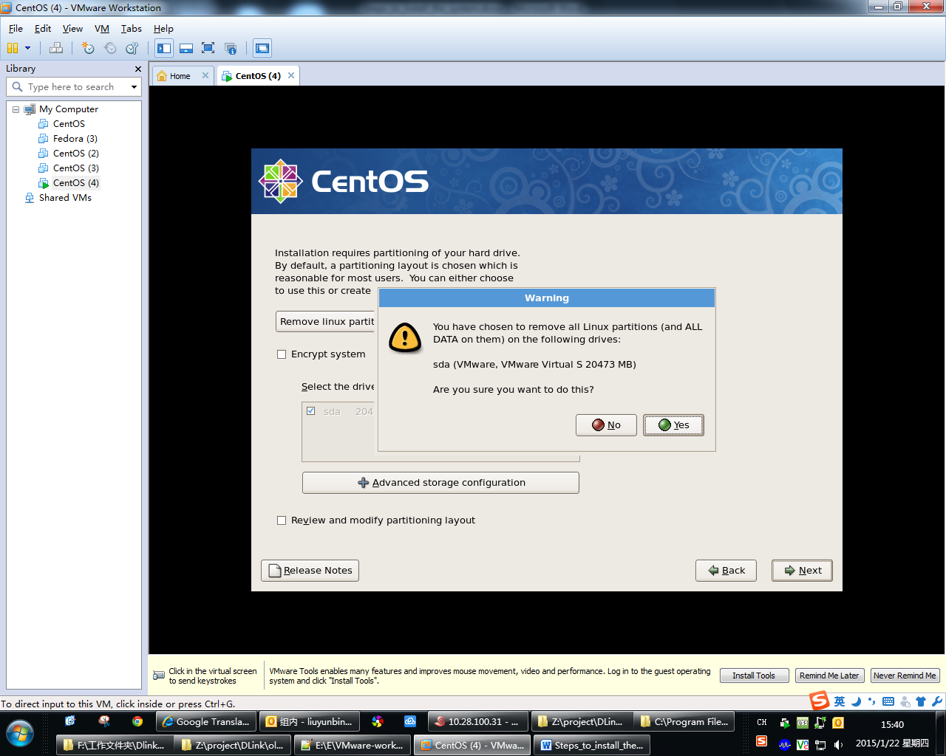

Step Twenty: please set the following screenshot. Then click “Next”.

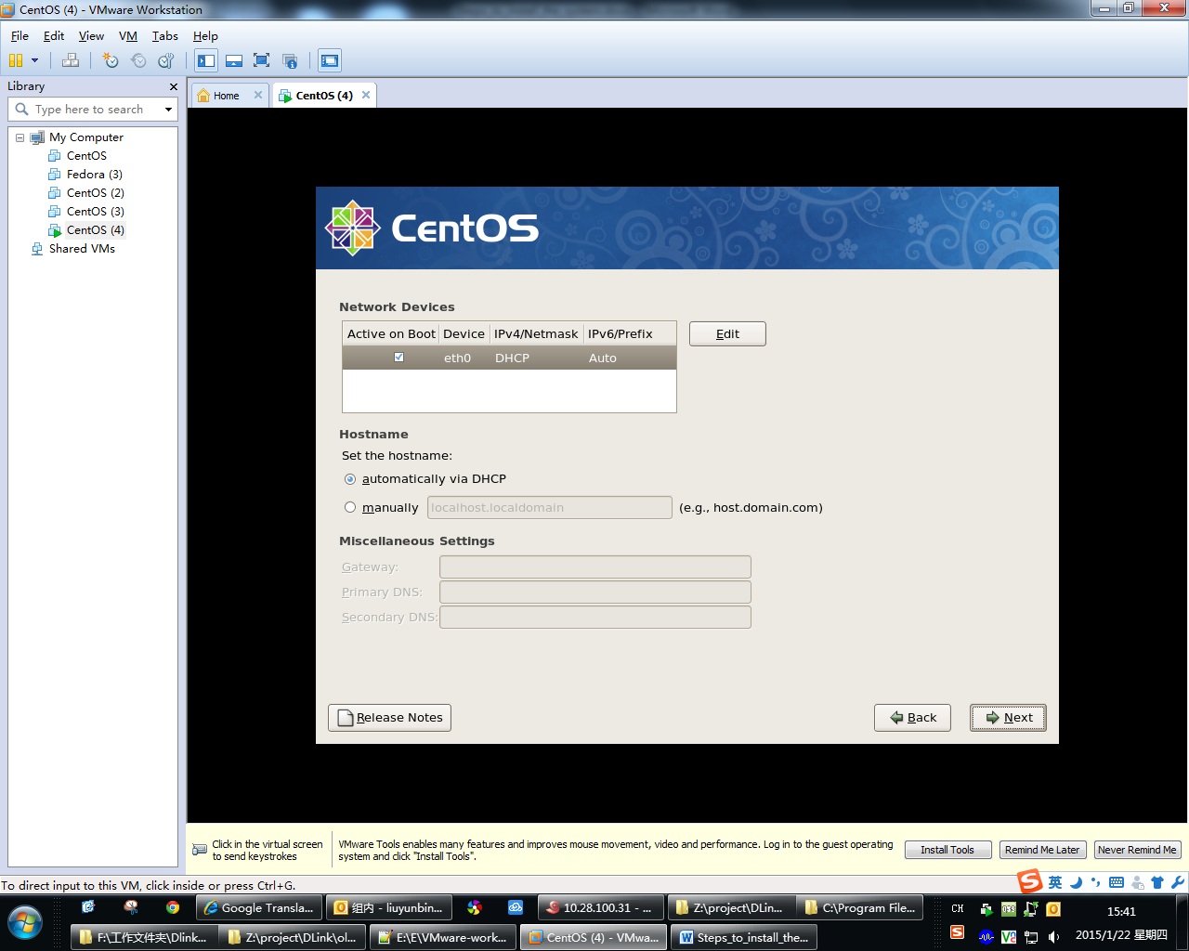

Step Twenty-one: please set the following screenshot. Then click “Next”.

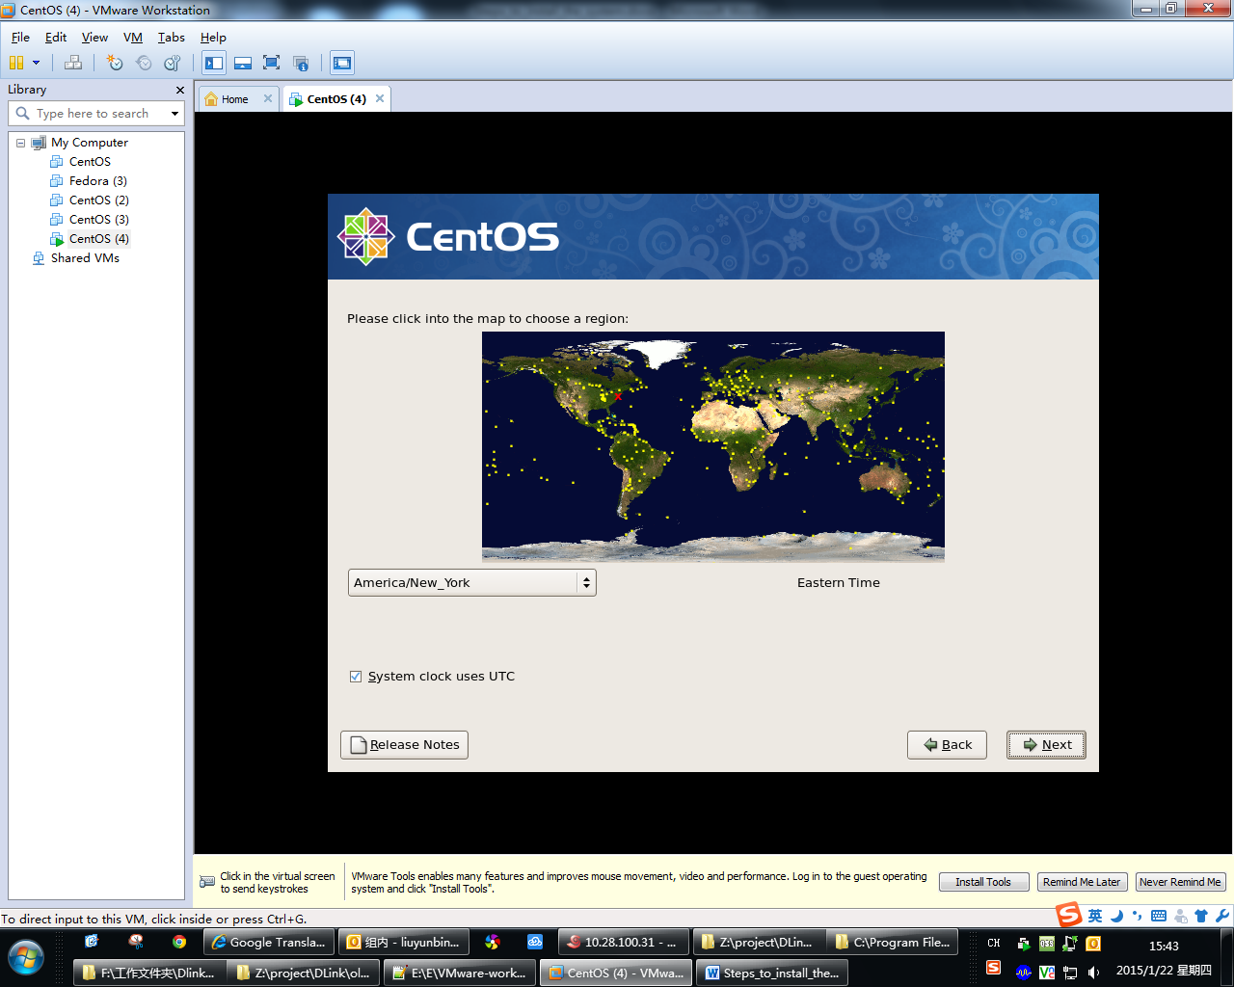

Step Twenty-two: set root password. Then click “Next”.

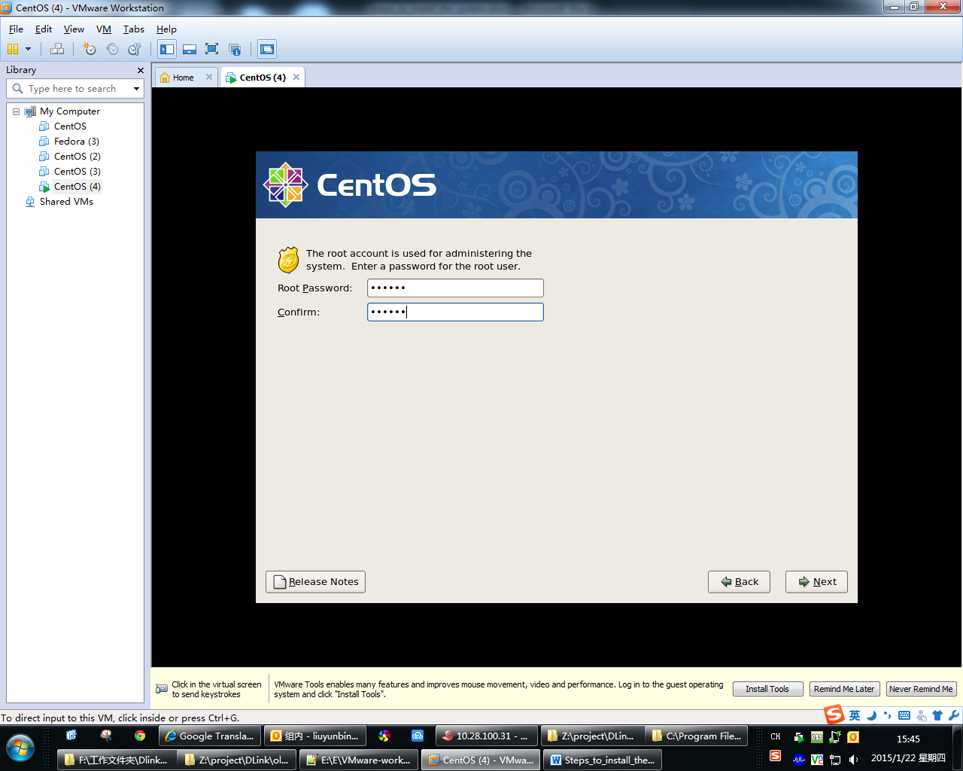

**Step Twenty-three: The step is very important, we must select** **“Customize now” to Manually install the software.** **Otherwise, the system may not function properly compile software. Then click “ Next”.**

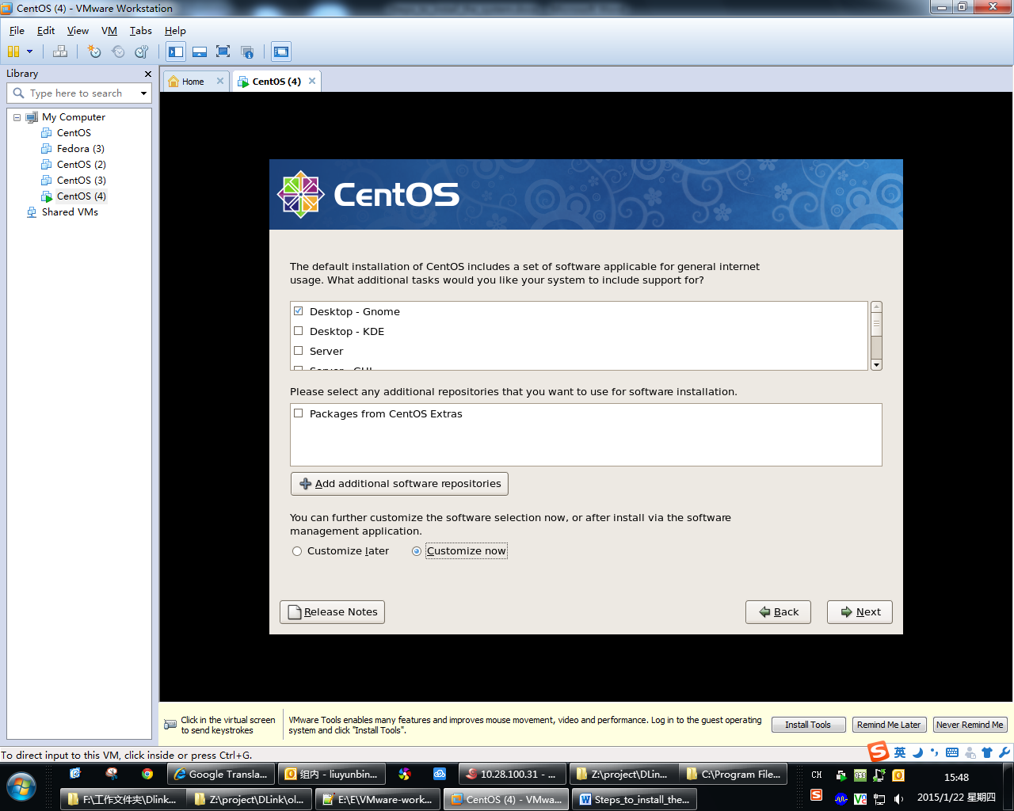

Step Twenty-four: select “Destktop Environments” on the left and check all the options on the right. Then select “Development” on the left.

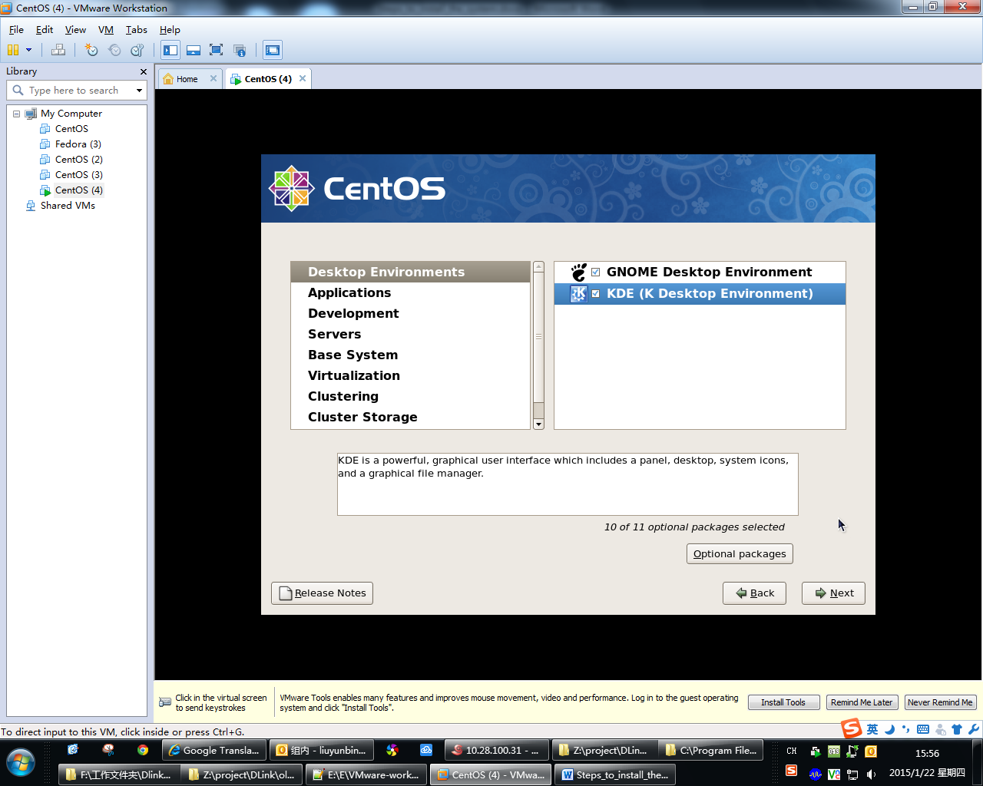

Step Twenty-five: if you have select “Development” on the left, check all the options on the right. Then select “Servers” on the left.

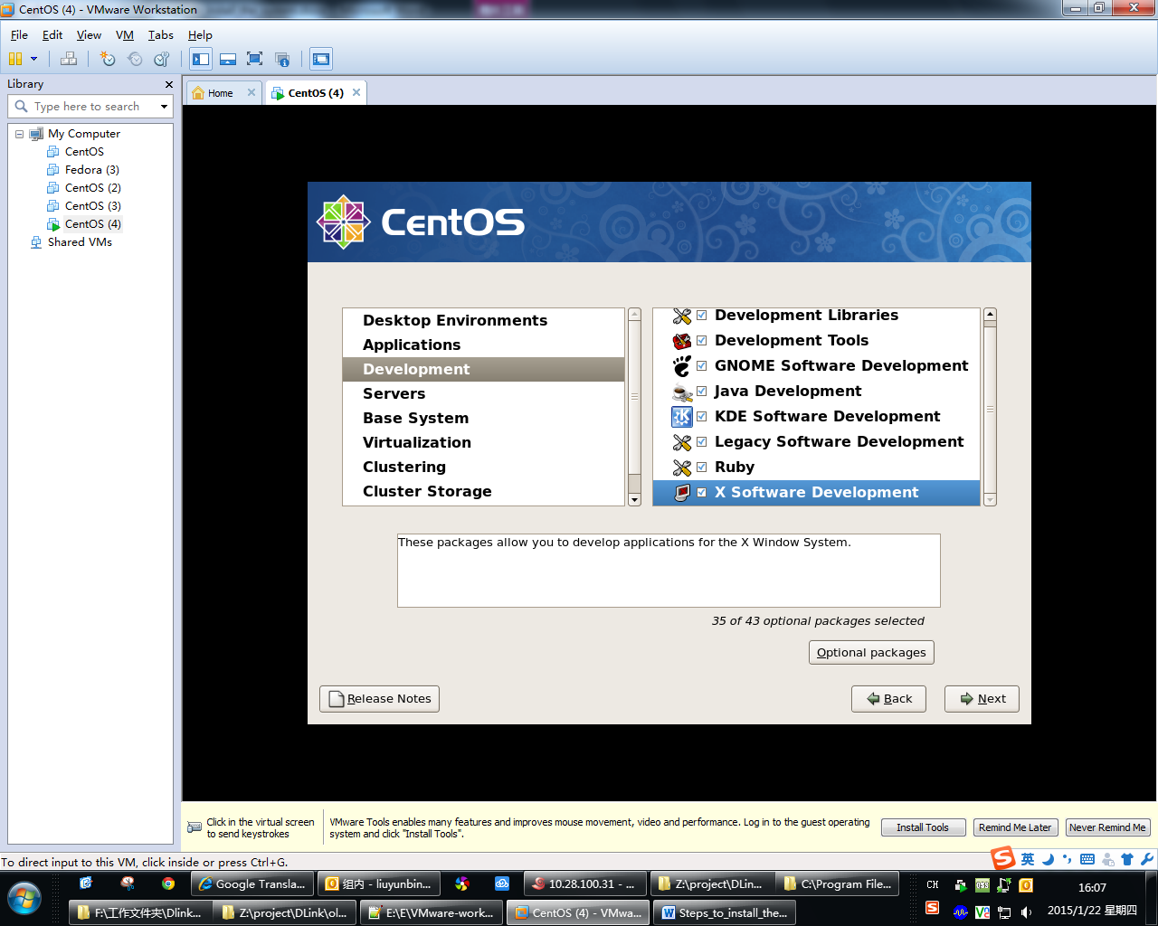

Step Twenty-six: if you have select “Servers” on the left, check all the options on the right. Then select “Base System” on the left.

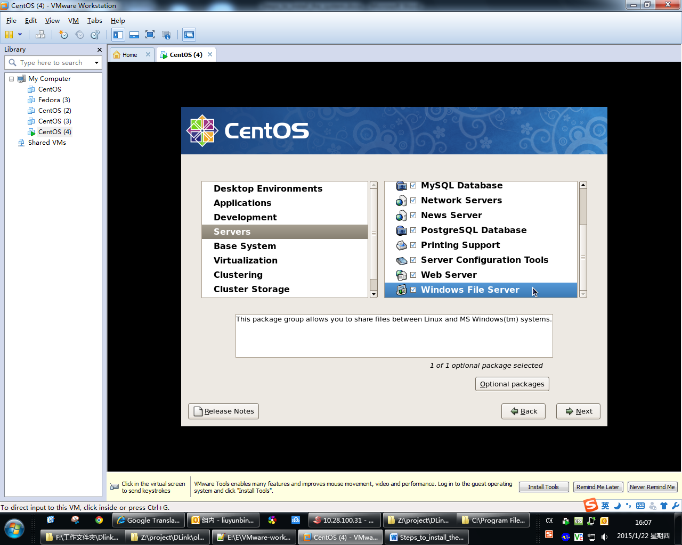

Step Twenty-seven: if you have select “Base System” on the left, check all the options on the right. Then select “Virtualization” on the left.

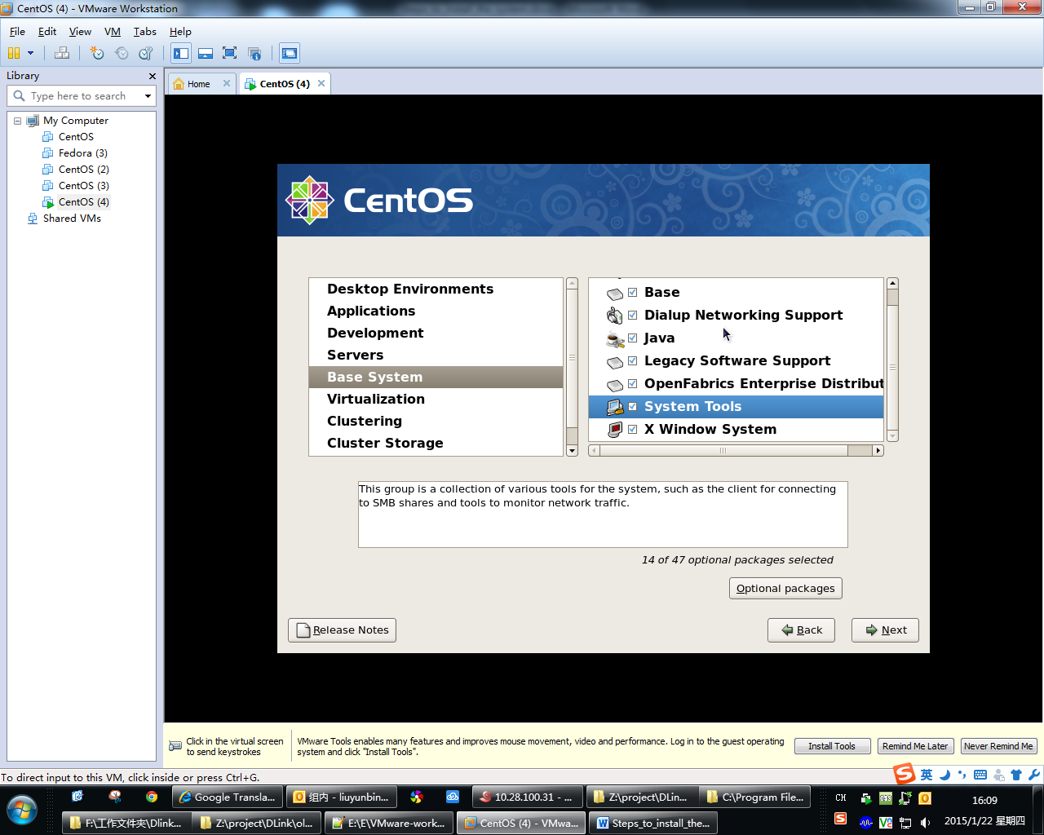

Step Twenty-eight: if you have select “Virtualization” on the left, check all the options on the right. Then select “Clustering” on the left.

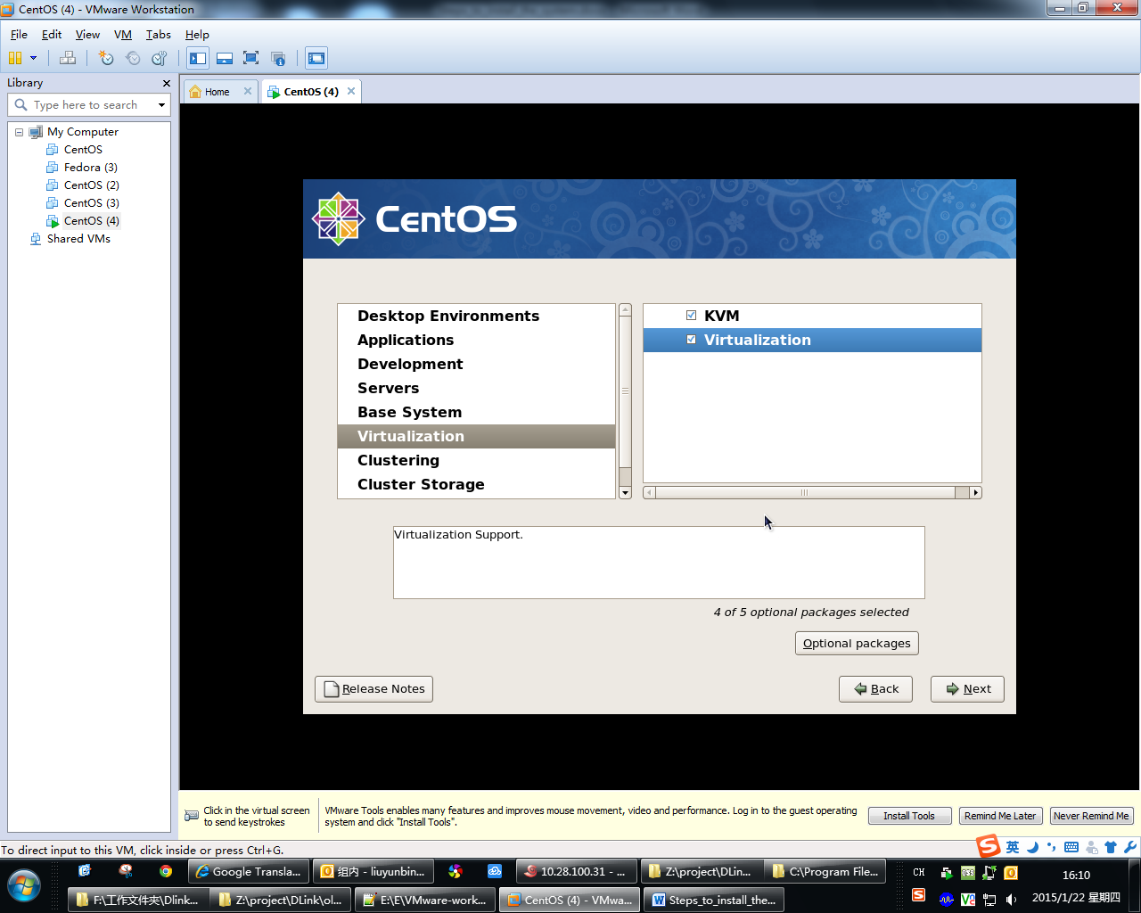

Step Twenty-nine: if you have select “Clustering” on the left, check all the options on the right. Then select “cluster Storage” on the left.

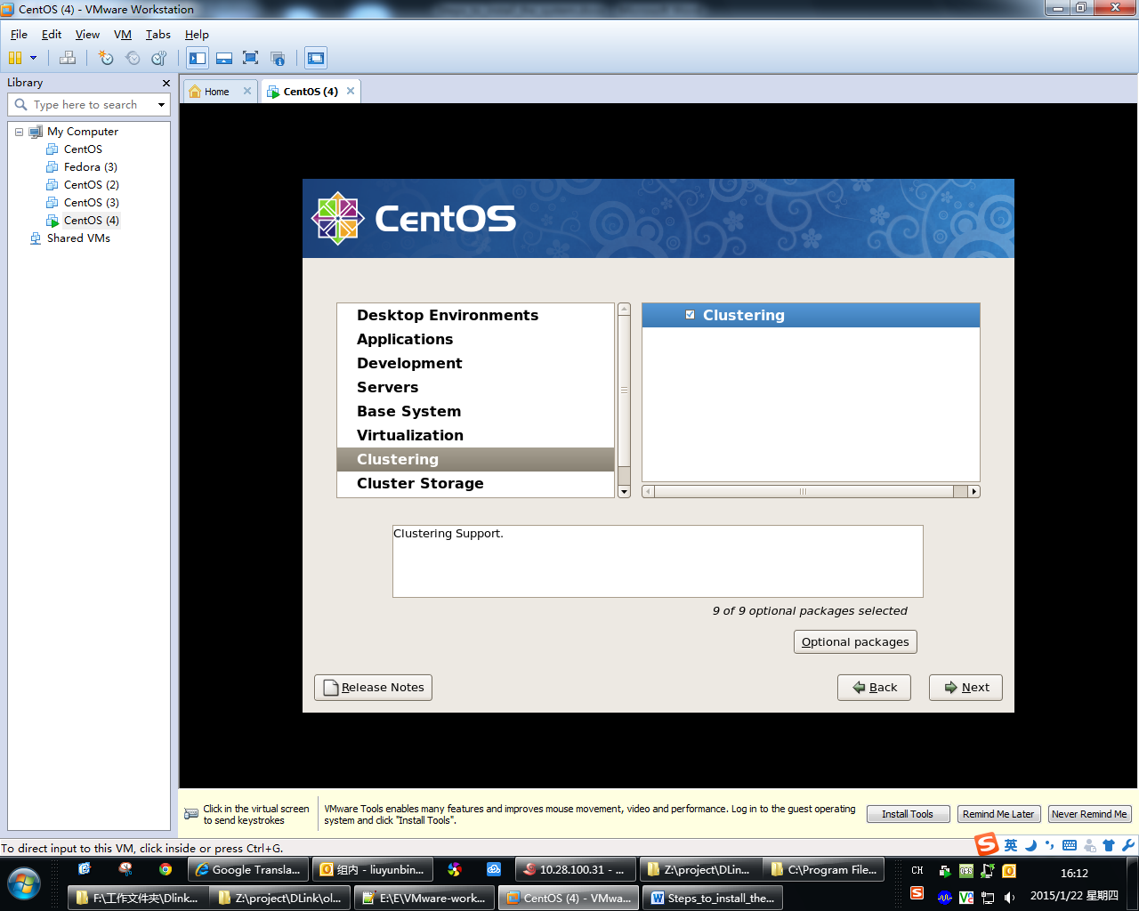

Step thirty : if you have select “cluster Storage” on the left, check all the options on the right. To this step, the software select is complete. Click “Next”.

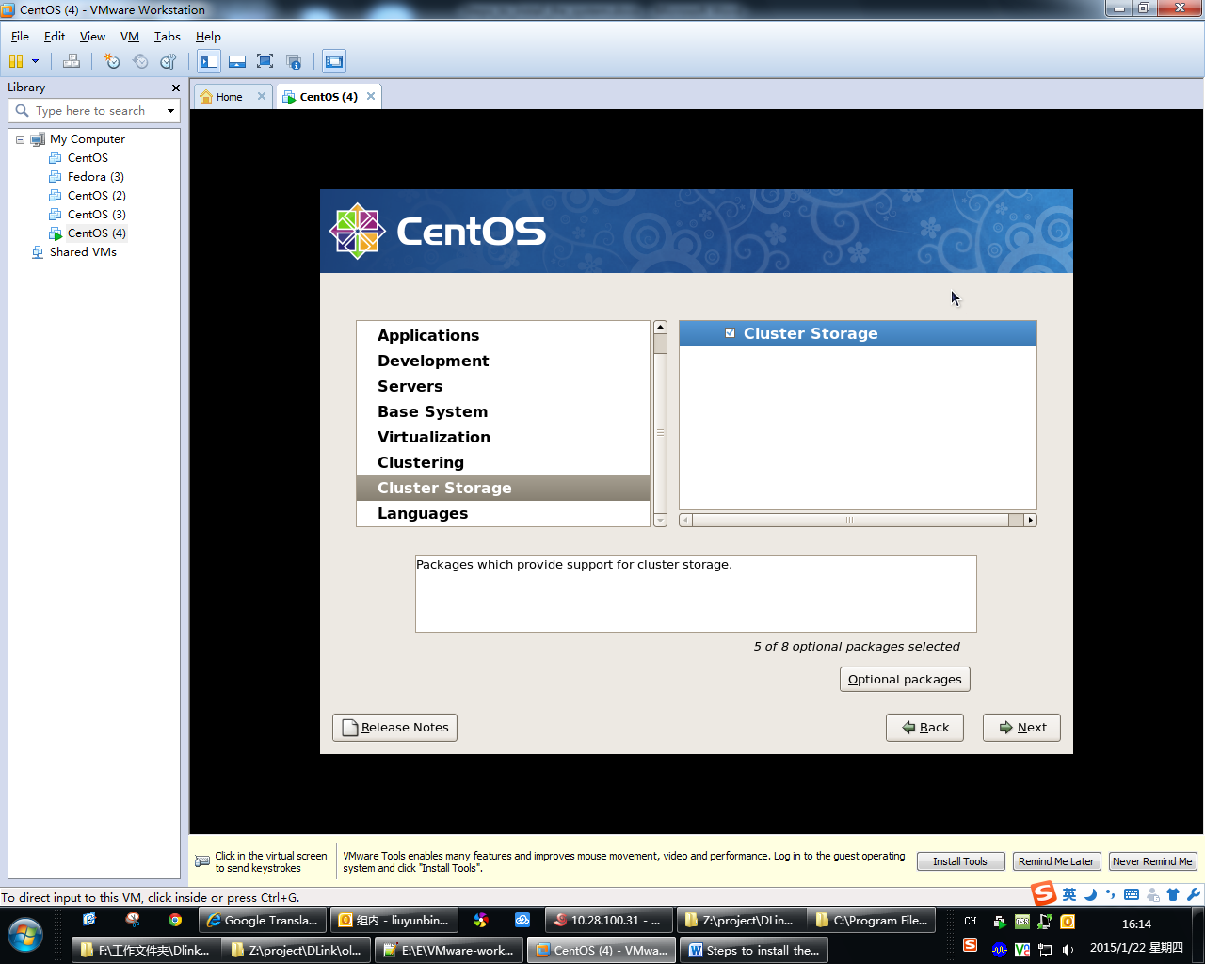

Step thirty-one: click “Next” to begin installation of system.

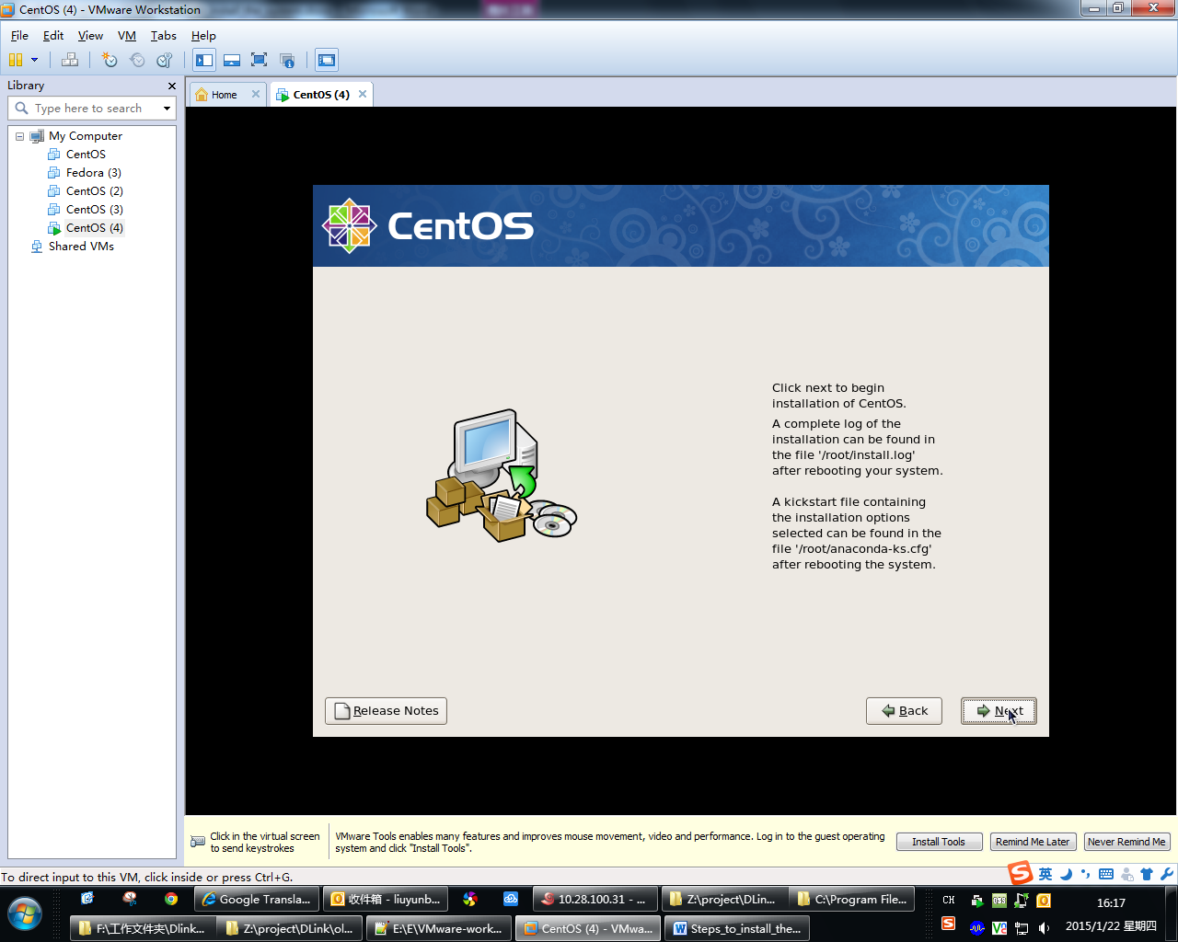

Step thirty-two: if the installation is complete, you need to reboot the system. Click “Reboot” to reboot the system

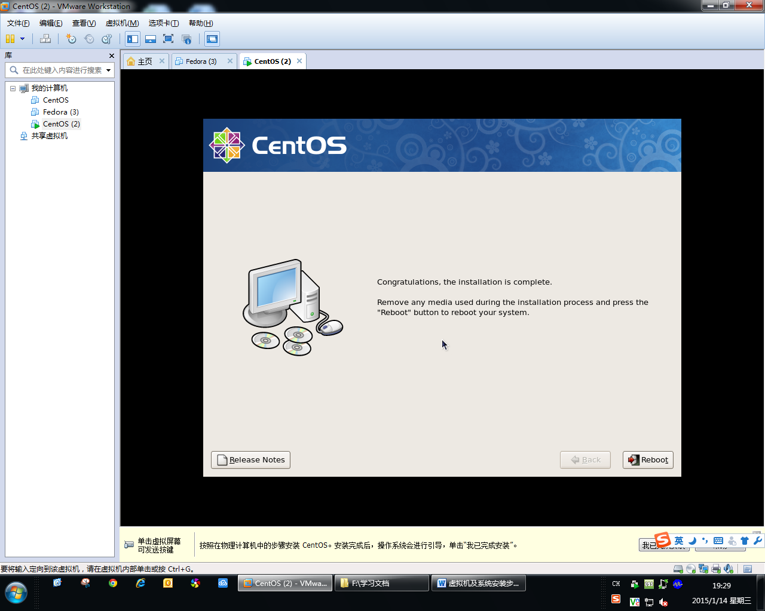

Step thirty-three: After the startup is complete, you will into the system setup wizard.

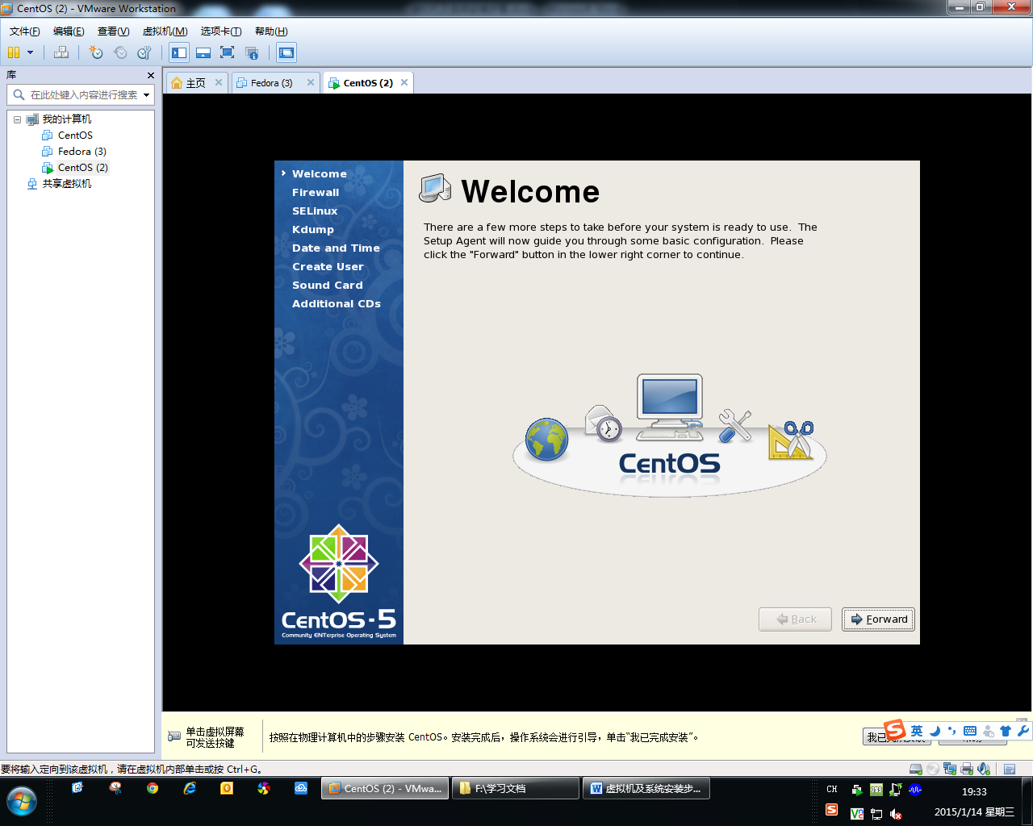

Step thirty-four: set the firewall as following. Then click “Forward”

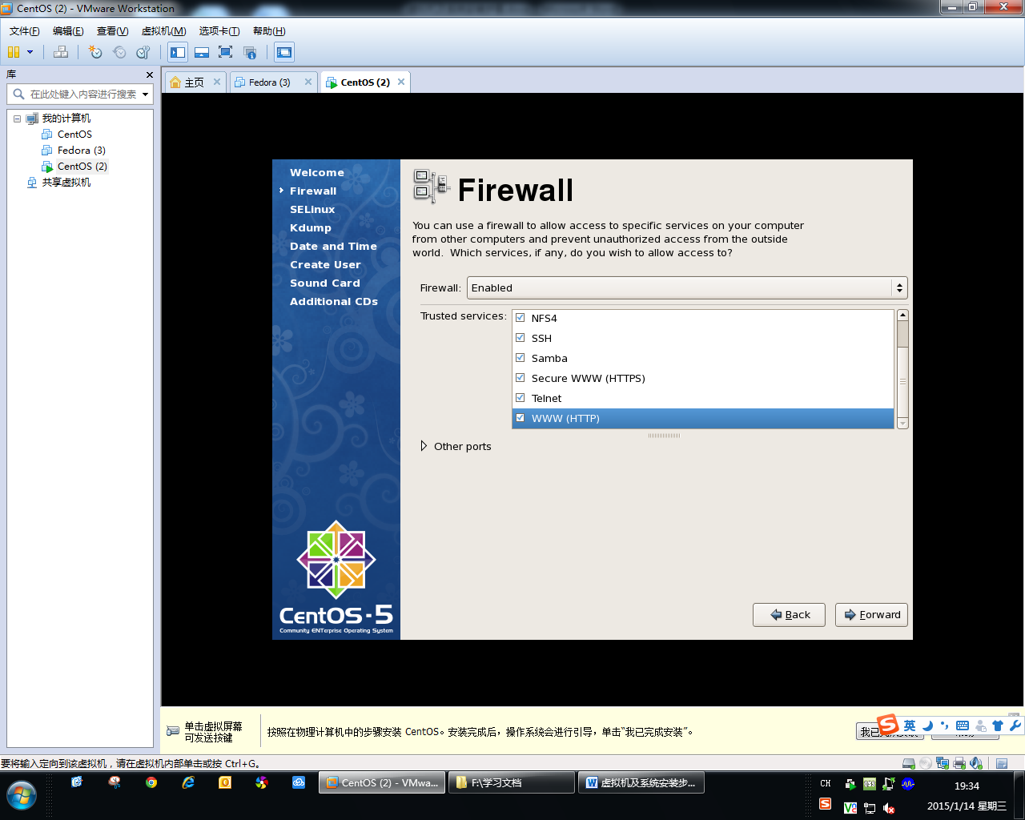

Step thirty-five: select “Yes” to next.

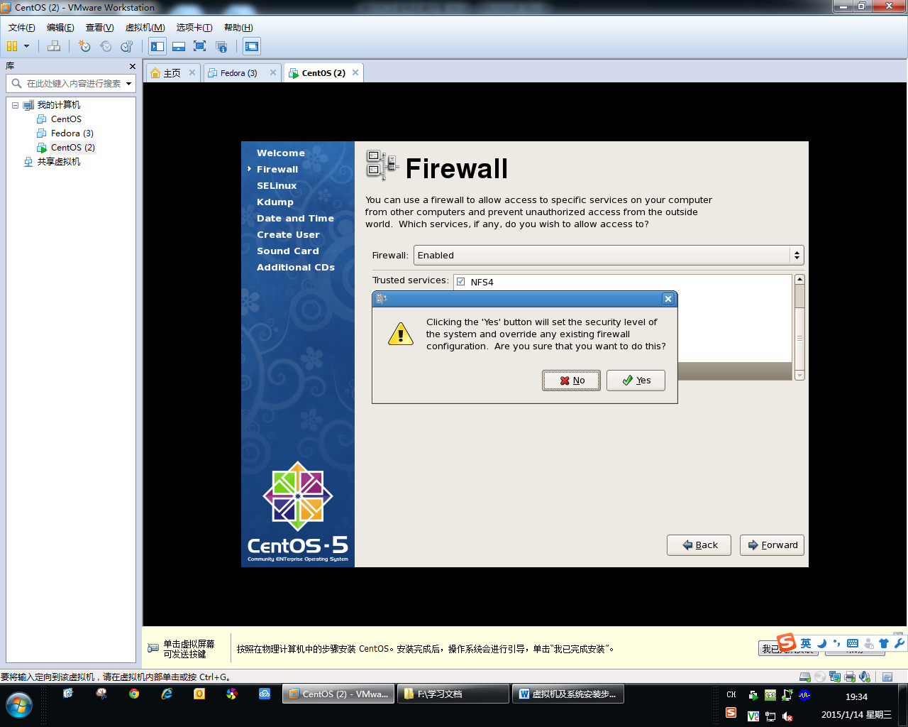

Step thirty-six: select “Disable” for SELinux. Then click “Forward”.

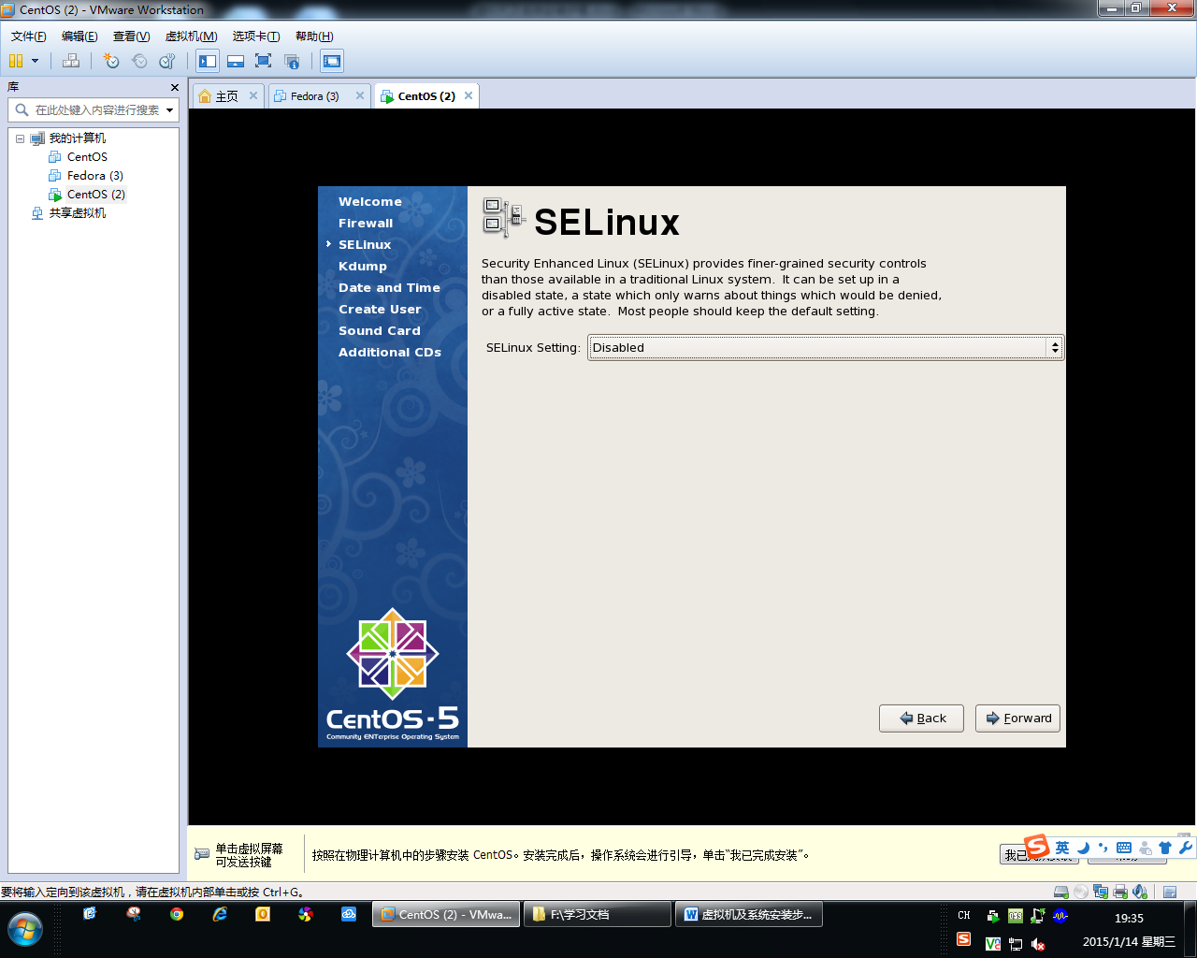

Step thirty- Seven: select “Yes” to next.

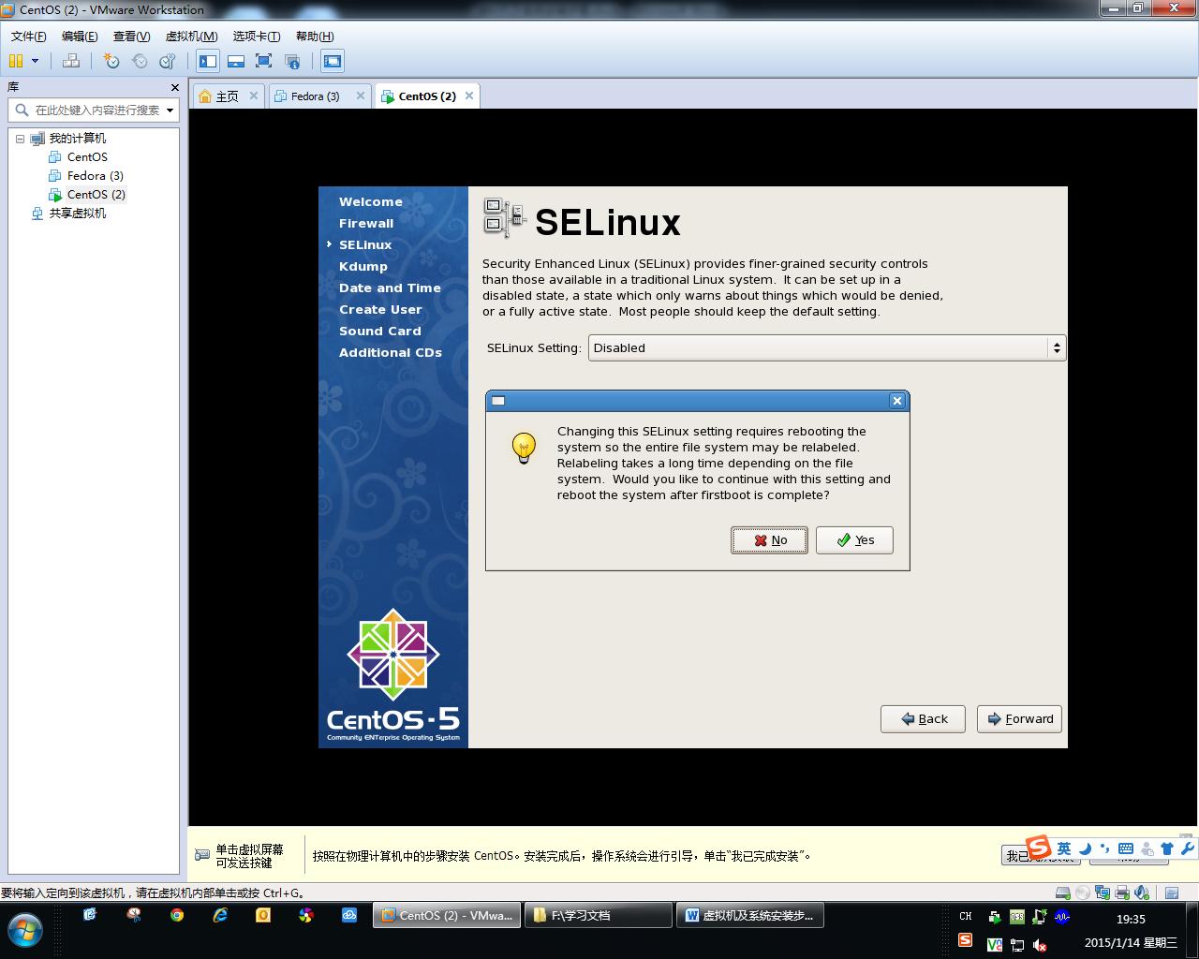

Step thirty- eight: Disable kdump. Then click “Forward”

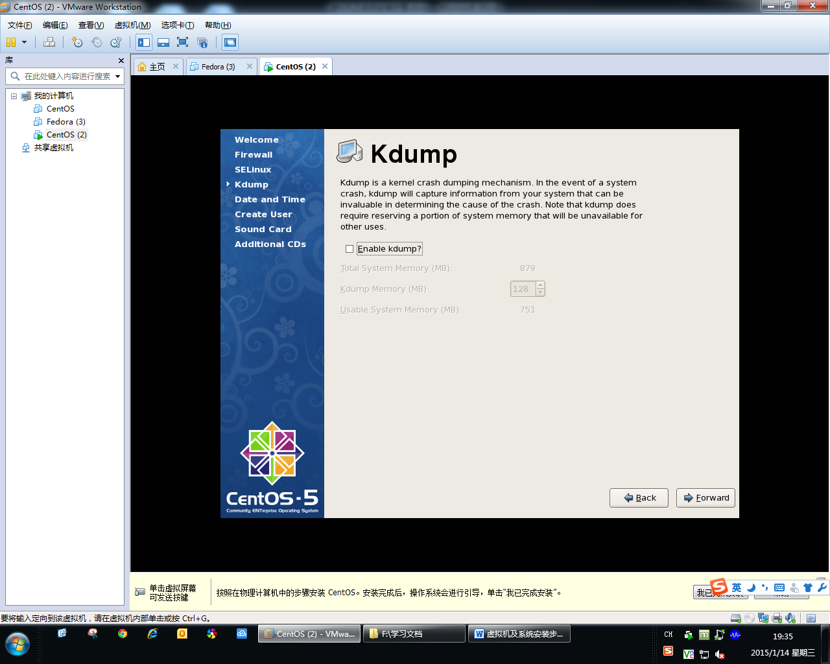

Step thirty-nine: set date and time. Then click “Forward”.

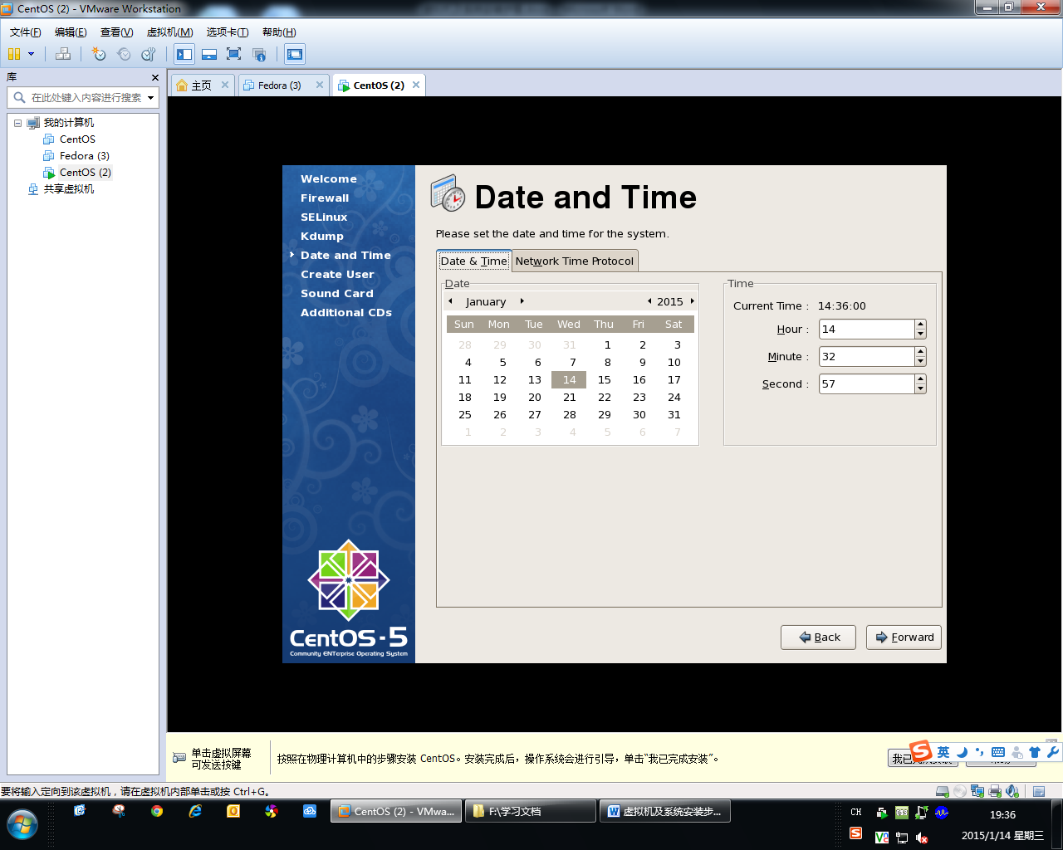

Step Forty: create user . Then click “Forward”.

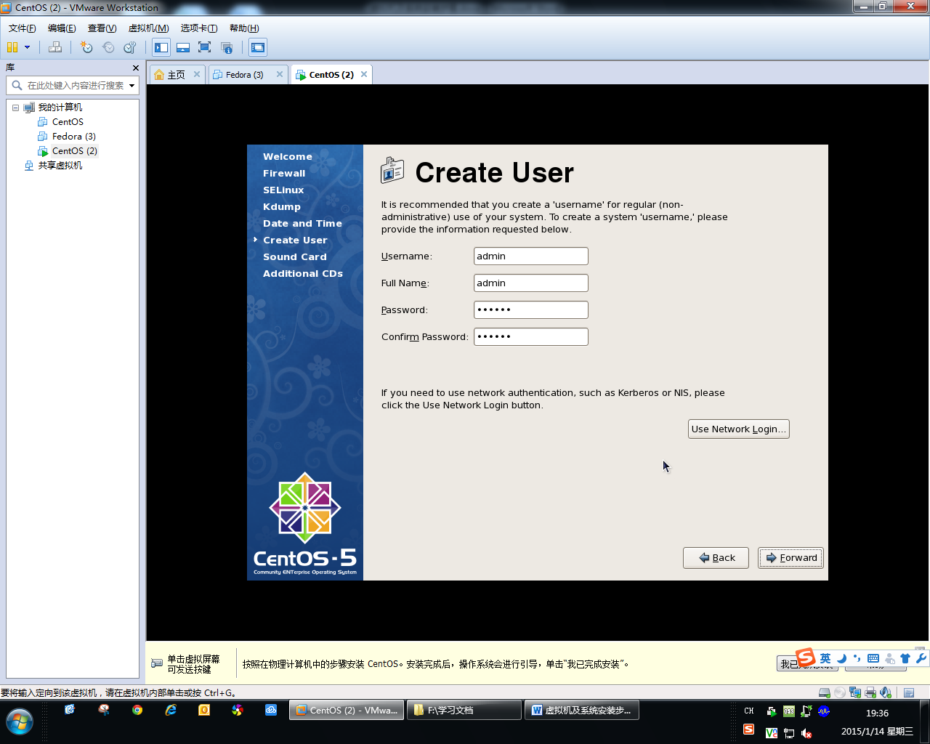

Step Forty-one: set sound card. Then click “Forward”.

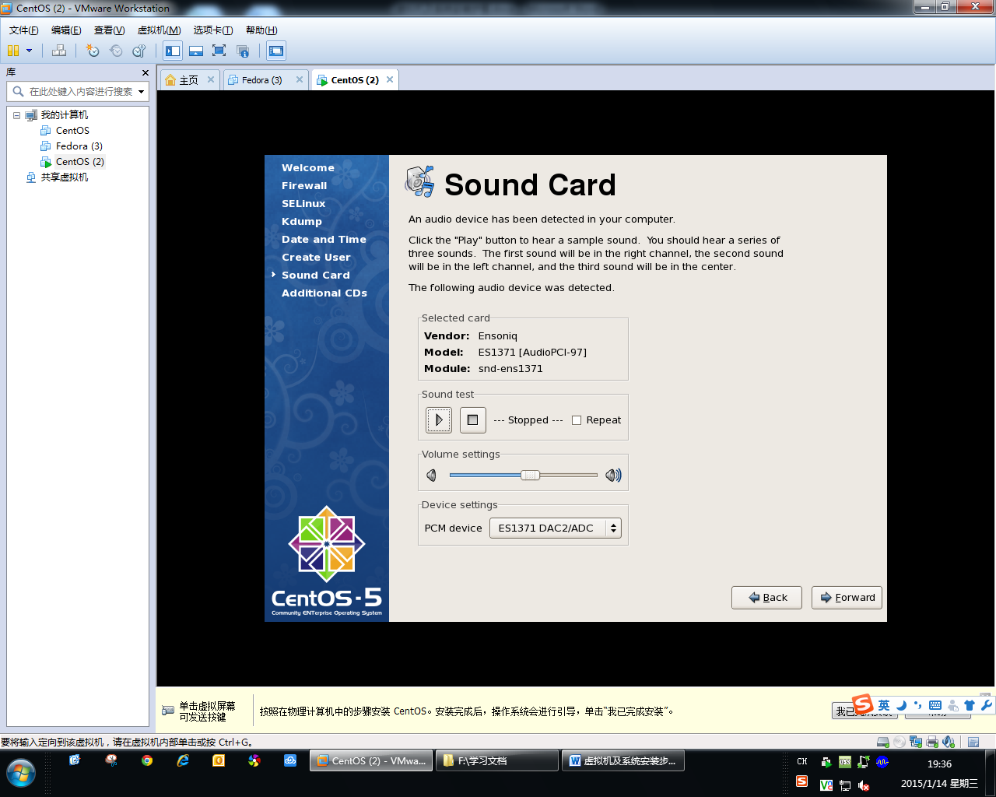

Step Forty-two: click “Finish”.

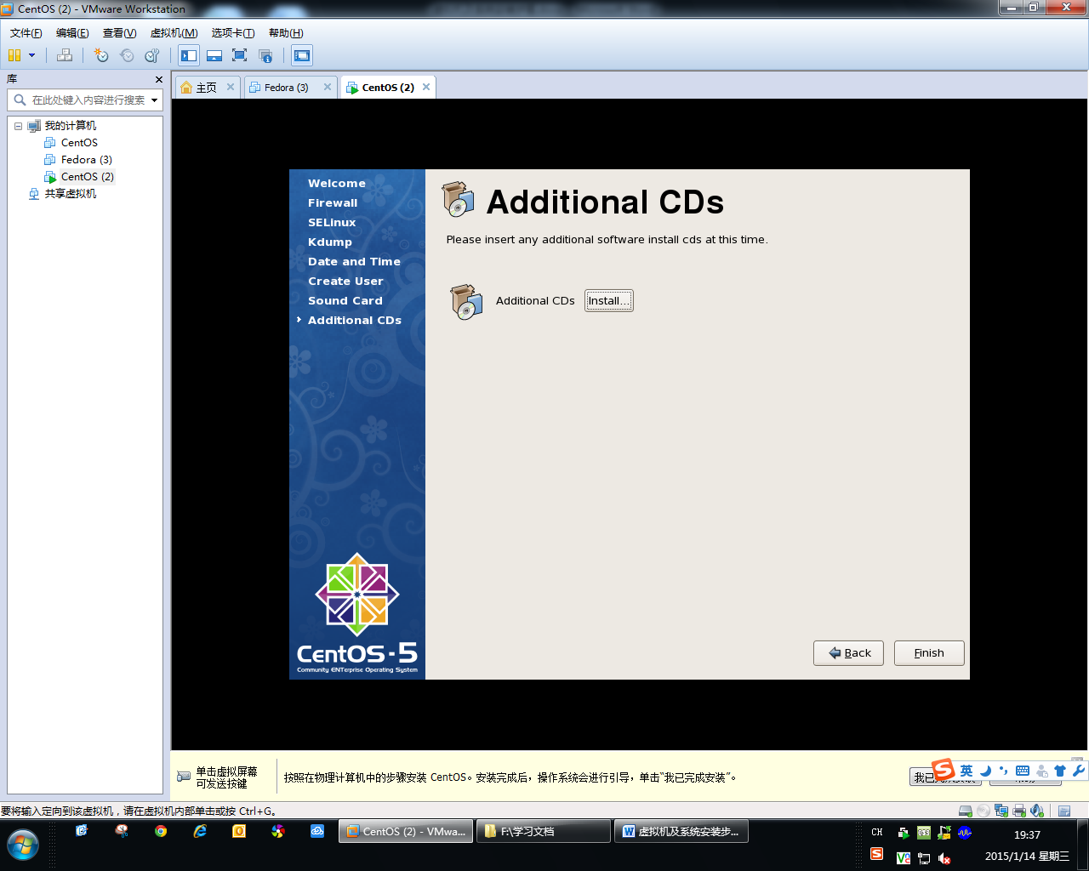

Step Forty-three: click “ok” to reboot system. Then go to see “readme” file how to make GPL.

